# 

# **Presentation**

**Dear teachers**

This is unit 1 of Fifth Grade Teacher´s Guide and have the purpose to provide English teachers of Fifth grade with the guidelines on how to develop effectively the knowledge, skills and abilities set in the new English syllabus. As a result, learners can achieve an expected level of performance in the target language according to the CEFR. We believe that you know your students best and therefore we encourage you **to adapt and contextualized** what you find here so that it responds to the needs and context of your learner. This lesson plan includes in the first page of the planning template, the four dimensions of the new Curricular Policy, “To Educate for a New Citizenship”. The ones mostly emphasized in the unit are identified with an X. These dimensions are embedded and developed in the learning experiences provided. This unit will be completed within a timeline of six weeks.

The unit includes all the steps that should be followed in the pedagogical mediation which are:

1. **Assessment Strategies and Evidences of Learning:** Each goal has a specific assessment indicator for each linguistic competence that requires the elaboration of assessment instruments. Sample models of rubrics are provided
2. **Goals:** Each lesson has specific and clear learning goals connected to a domain, scenario, theme and language function.
3. **Pedagogical Mediation/ Didactic Sequence:** subdivided in the following stages;

* **Pre-Teaching:** (Warm-up, Activation of Prior Knowledge, Modeling, Clarifying)
* **Pre-task:** Introductory activity for activation of students’ prior knowledge to carry out a specific task connected to a goal. It places emphasis on the linguistic, cognitive resources needed by the leaner.
* **Task rehearsal:** Class work where students practice the language in a meaningful way for successful task completion.
* **Task completion:**  A task that learners perform to demonstrate that the goal has been successfully achieved.
* **Task assessment:** An activity for reinforcement of the goal. It can also be used for self-and/or peer assessment and teacher feedback and/ or repair in relation to the achievement of a goal. Evaluation tools to evaluate performance tasks, of what students know and can do.

1. **Time:** Each phase of the didactic sequence includes a suggestion for the time that may be needed.
2. **Integrated Mini Project:** The project is a creative opportunity for students to integrate knowledge, abilities and skills**.**
3. **Reflective Teaching:** Suggestions for you to assess your own progress in teaching the material.
4. **Enduring Understanding Reflection**: Space to record how students grasped new understandings and ideas in connection with the essential question of the unit.

We hope that this effort will help you to customize your teaching in an effective, creative, engaging, and interactive way in response to your students ‘needs. This unit offers a variety of activities for each phase of the lesson plan; the teacher selects those that are appropriate for achieving the learning goals, the context and learners needs, and the numbers of lesson available for teaching English in the school.

|  |  |  |  |  |
| --- | --- | --- | --- | --- |
| **Level 5th Unit 4**  **Scope and Sequence** | | | | |
| |  | | --- | | **Dimensions** | | **1.** **Ways of thinking (  )** | | **2. Ways of living in the world  (x)** | | **3. Ways of relating with others  ( )** | | **4. Tools for integrating with the world  ( )** | | | | | |
| **Scenario: Healthy Choices, Better Life** | | | | |
| **Enduring Understanding** | Almost every day, we do things like count, measure, estimate, and calculate to get things done. We use numbers in sports and shopping. These actions help us be more confident in our decisions and they help us communicate our needs. | | | |
| **Essential Question** | How do we quantify our world every day to lead better lives? | | | |
| **Assessment and Goals** | | | | |
| **Week 1** | **Week 2** | **Week 3** | **Week 4** | **Week 5** |
| **Theme**   1. Uhm! I’m Hungry | **Theme**  2. What did You Cook? | **Theme**   1. Let´s Stay in Shape | **Theme**   1. Healthy Lifestyles | **Assessment**  **Instruments for Process/Product**  **Week 6**  **Suggested Integrated Mini project** |
| **Assessment:** | **Assessment:** | **Assessment:** | **Assessment:** |
| **L.1.** Recognizes the most important points in a straightforward talk or presentation, accompanied with drawings and/or diagrams, provided there is some previous familiarity with the topic. | **L.2.** Recognizes short, clear, and simple instructions and explanations when delivered slowly (e.g., first, you add... then, you mix...). | **SI.1.** States single step directions/ commands using words and phrases. | **SI.3.** Makes and accepts suggestions. |
| **R1.** Recognizes readings, analyzes and enjoys texts. | **R2.** Recognizes much of what is written in short, simple texts on subjects with which they are familiar and/or in which they are interested. | **W1.** Prepares simple reminders or notes for personal use (e.g., diary, journal, homework book). | **W2.** Copies dates and facts from short, simple text. |

|  |  |  |  |  |
| --- | --- | --- | --- | --- |
| **SI.2.** Presents a dialogue with a group, it has main ideas and two to three details. | **SP.1.** Describes their favorite recipe, how to prepare it, and possible length of time and nutritious value. | **PA.2.** Shows knowledge of phonemic awareness by pronouncing the sound /-t//-d/ at the end of words. | **PA.2.** Shows knowledge of phonemic awareness by pronouncing the sound /-t//-d/ at the end of words. |  |
| **PA.1.** Shows knowledge of phonemic awareness by reading consonant blends (bl, st, and tr) | **PA.1.** Shows knowledge of phonemic awareness by reading consonant blends (bl, st, and tr) |
| **Goals** | **Goals** | **Goals** | **Goals** |
| **L.1.** understand the most important points in a straightforward talk or presentation, accompanied with drawings and/or diagrams, provided there is some previous familiarity with the topic. | **L.2.** understand short, clear, and simple instructions and explanations when delivered slowly (e.g., first, you add... then, you mix...). | **SI.1.** state single step directions/ commands using words and phrases. | **SI.3.** make and accept advice. |
| **R1.** comprehend reading, analyze and enjoy texts. | **R2.** understand much of what is written in short, simple texts on subjects with which they are familiar and/or in which they are interested. | **W1.** prepare simple reminders or notes for personal use (e.g., diary, journal, homework book). | **W2.** copy dates and facts from short, simple text. |
| **SI.2.** present a dialogue with a group, it has main ideas and two to three details. | **SP.1.** describe their favorite recipe, how to prepare it, and possible length of time and nutritious value. | **PA1.** demonstrate knowledge of phonemic awareness. | **PA1.** demonstrate knowledge of phonemic awareness. |
| **PA1.** demonstrate knowledge of phonemic awareness. | **PA1.** demonstrate knowledge of phonemic awareness. |  |  |

|  |  |  |  |  |
| --- | --- | --- | --- | --- |
| **Function** | **Function** | **Function** | **Function** |  |
| * Describing food likes/dislikes * Describing similarities and differences | * Describing procedures for quantifying items | * Describing habits and routines | * Describing healthy lifestyles |
| **Discourse Markers** | **Discourse Markers** | **Discourse Markers** | **Discourse Markers** |
| Sequence adverbs-past tense  First, next, then, finally | Sequence adverbs-past tense  First, next, then, finally | Sequence adverbs-past tense  First, next, then, finally | Sequence adverbs-past tense  First, next, then, finally |
| **Grammar & Sentence Frames** | **Grammar &Sentence Frames** | **Grammar & Sentence Frames** | **Grammar & Sentence Frames** |
| Present simple and preferences   * I like to eat vegetables, but I don’t like meat. * She likes spinach, but she does not like carrots.   Comparative and superlative adjectives.   * Vegetables are more delicious than fried food. * Running is better than walking. * Running is the best exercise   WH questions   * What’s your favorite food? | Past simple   * They cooked … * I mixed… * I prepared...   WH questions   * How did you prepare it?   Prepositional phrases   * The food is on the table. * The ingredients are on the counter. * Place the pot on the stove. | Future with will   * I am overweight so I will go on a diet. * I will eat healthy food.   Comparative and superlative adjectives.   * Running is better than walking. * Running is the best exercise.   WH questions   * How often do you do exercise? | Simple Present and Frequency Adverbs   * I usually eat/drink \_\_\_\_\_. * I exercise once/twice a week.   Future with going to   * I am going to eat healthier. * I am going to do more exercise.   Modal should   * We should not eat junk food frequently. |
| **Phonemic Awareness** | **Phonemic Awareness** | **Phonemic Awareness** | **Phonemic Awareness** |
| Reading regularly spelled two-syllable and compound words including consonant blends. (bl, st, and tr) | Reading regularly spelled two-syllable and compound words including consonant blends. (bl, st, and tr) | Practicing minimal pair sounds: /-t / - heart/ plate/ bet/ bought/ /-d/ hard, played, bed, bored | Practicing minimal pair sounds: /-t / - heart/ plate/ bet/ bought/ /-d/ hard, played, bed, bored |

|  |  |  |  |  |
| --- | --- | --- | --- | --- |
| **Vocabulary** | **Vocabulary** | **Vocabulary** | **Vocabulary** |  |
| 1. Uhm! I’m Hungry  Questions and expressions:   * What’s your favorite meal/ food? * What do you usually eat for lunch? * I am hungry. * I want/ I like…   Food & Drinks   * Vegetables: Broccoli, cabbage, tomatoes. * Fruits: pineapple, strawberry, Meals: * rice with chicken, spaghetti, Meats: * beef, lamb, chicken, | 2.Recipes and more  Expressions and phrases   * What a delicious meal! * How did you prepare it?   Quantities and amounts   * a little, a lot, a kilo, a bottle, a bar, a tin/can   Sequence words   * First, second, then, finally   Verbs   * Boil, grill, bake… | 3.Let´s keep in shape  Expressions and phrases   * What are you doing to keep in good shape? * Where are you going after school? I’m going to ride my bike. * What are you eating for dinner? * Let’s practice sports.   Activities   * Going to the gym * Playing soccer with my friends * Eating healthy food. * Running in the park. * Swimming in the river/swimming pool. * Practicing a sport | 4.Healthy Lifestyles   * How can we keep healthy? * Let´s make a health campaign at school. * Taking care of the body * I have to… I should... * Take a bath/ shower * Brush teeth * Use dental floss * Drink a lot water * Wash hands after using toilets and before meals * Eating healthy food |
| **Psycho-social** | **Psycho-social** | **Psycho-social** | **Psycho-social** |
| * Respecting other people’s customs and habits | * Respecting other people’s customs and habits | * Leading a healthy life | * Leading a healthy life |
| **Sociocultural** | **Sociocultural** | **Sociocultural** | **Sociocultural** |
| * Sharing different lifestyles | * Sharing different lifestyles | * Promoting healthy food and healthy habits | * Promoting healthy food and healthy habits |
| **Idioms/phrases** | **Idioms/phrases** | **Idioms/phrases** | **Idioms/phrases** |
| * Butter someone up (be extra nice with someone) Cheesy (silly) | * Cool as a cucumber (very relaxed) | * Full of beans (lively, active and healthy) | * In bad shape (poor physical condition) |

|  |  |  |  |  |  |
| --- | --- | --- | --- | --- | --- |
| **Term:** | **Level: Fifth Grade** | | **Unit: 4** | | **Week:1** |
| **Domain: Socio-interpersonal** | | **Scenario: Healthy Choices, Better Life** | | **Theme:**  Uhm! I’m Hungry | |
| Almost every day, we do things like count, measure, estimate, and calculate to get things done. We use numbers in sports and shopping. These actions help us be more confident in our decisions and they help us communicate our needs. | | | | | |
| **Essential Question:**  How do we quantify our world every day to lead better lives? | | | | | |
| |  | | --- | | **Dimensions** | | **1.** **Ways of thinking (X)** | | **2. Ways of living in the world  (X)** | | **3. Ways of relating with others  ( )** | | **4. Tools for integrating with the world  ( )** | | | | | | |
| **Learn to Know** | | **Learn to Do** | | **Learn to Be and Live in Community** | |
| **Grammar & Sentence Frames**  *Present simple and preferences*   * I like to eat vegetables, but I don’t like meat. * She likes spinach, but she does not like carrots.   *Comparative and superlative adjectives.*   * Vegetables are more delicious than fried food. * Running is better than walking. * Running is the best exercise   *WH questions*  What’s your favorite food?  **Phonemic Awareness**  Reading regularly spelled two-syllable and compound words including consonant blends. (bl, st, and tr)  **Vocabulary**  *Questions and expressions:*   * What’s your favorite meal/ food? * What do you usually eat for lunch? * I am hungry. * I want/ I like…   *Food & Drinks:*   * Vegetables: Broccoli, cabbage, tomatoes. * Fruits: pineapple, strawberry, blueberry, trigo * Meals: rice with chicken, spaghetti. * Meats: beef, lamb, chicken, | | **Function**  Describing food likes/dislikes  Describing similarities and differences  **Discourse Markers**  Sequence adverbs-past tense  First, next, then, finally | | **Psycho-social**  Respecting other people’s customs and habits  **Socio-cultural**  Sharing different lifestyles  **idioms/ phrases**   * Butter someone up (be extra nice with someone)  * Cheesy (silly) | |

|  |  |  |  |
| --- | --- | --- | --- |
| **Assessment Strategies & Evidences of learning**  (Diagnostic, formative, summative) | **Goals** |  | **Time** |
| Learner…  **L.1.** Recognizes the most important points in a straightforward talk or presentation, accompanied with drawings and/or diagrams, provided there is some previous familiarity with the topic.  **L1.1.** gets the gist of the most important points in a straightforward talk or presentation about healthy lifestyles related with food, provided there was some previous familiarity with the topic, by completing a chart. | Learner can …  **L.1.** understand the most important points in a straightforward talk or presentation, accompanied with drawings and/or diagrams, provided there is some previous familiarity with the topic. | ***CONNECTION***  **Pre-teaching**  *The teacher sets the classroom, leads the routine and quickly checks the attendance, then announces the beginning of a new unit and theme and write them on the board. Creative teachers can display a chart with the essential question, enduring understanding and the idioms they will study during this week.*  **Warm up**  The teacher invites learners to singing the song “I like apples, yummy, yummy, yummy” <https://www.youtube.com/watch?v=KC-8AvunL8Y> or “Healthy food vs Junk food” <https://www.youtube.com/watch?v=fE8lezHs19s> After singing, the teacher asks them to replace some fruits’ names by vegetables they might know.  **Activation of Prior Knowledge**  Based on the previous video T could ask students the following questions:   1. **What types of food do you know?** 2. **What types of food do you like to eat?** 3. **What types of food are healthy or unhealthy?**   Then the teacher sticks on the board four pictures about food: vegetables, fruits, meals and meat *(see pictures in annex T1)* Then S/he asks the learners to say foods they might know for each category while s/he writes on the board.    **Modeling**  After that, the teacher introduces the questions and the comparative and superlative forms for describing food, for example: *(See flashcards in annexesT2)*   |  |  | | --- | --- | | Questions | Ways to respond | | What is your favorite meal/food? | I love vegetables. Vegetables are more delicious than fried food. | | What is your favorite drink? | I like drinking water. Water is healthier than drinking sodas. | | What do you usually eat for breakfast/lunch/dinner? | For breakfast I like gallo pinto and scramble eggs, but I don’t like bread. | | What is the best food for a healthy lifestyle? | The healthiest foods are salads, fruits and vegetables. |   The teacher also models how to respond to those questions by using flashcards and models the use of the expressions I like …, but I don’t like …**,** as well as the comparative and superlative forms to describe food. *(See the flashcards in the annex T1)*  The teacher uses a video and the infographic to better understanding of the comparative and superlative form. **(**[**https://www.powtoon.com/s/bhmZUiZSqax/1/m**](https://www.powtoon.com/s/bhmZUiZSqax/1/m)**).**  **Infographic**    ***CLARIFICATION***  **Clarifying**  The teacher challenges students to compare the types using the adjectives in the middle. T asks students: **which food is healthier broccoli or French fries?**   |  |  |  | | --- | --- | --- | | FOOD | ADJECTIVE | FOOD | | Salads | Good | Soup | | Broccoli | Healthy | French fries | | Hamburgers | Delicious | Pizza |   ***CONNECTION***  **Pre-task**  Teacher shares the goal of the lesson.  Through the use of an interview, the teacher will make learners to get familiar with the new language and practice it with their classmates. S/he poses the following questions on the board and asks learners to interview each other by using the questions, then they have to switch places with others classmates in order to ask the same questions.   1. **What food do you like the least? …. I don’t like …** 2. **What food do you dislike the most? …. I love …**   **Task rehearsal**  Learners will listen to an audio for the first time to discover the food preferences between two friends.  ***Task.*** *Listen to a conversation about food preferences between two friends, Lucy and Jamal. Discover the foods they like or dislike, then based on the information heard fill in the chart.*    Look for the practice in annexes. Size is bigger there. <https://youtu.be/k-besF9yuHY> | 40 minutes |

|  |  |  |  |  |  |
| --- | --- | --- | --- | --- | --- |
| **L.1.2.** recognizes the most important key points in a straightforward talk or presentation, about healthy lifestyles accompanied with drawings and/or diagrams, provided there is some previous familiarity with the topic by solving a multiple-choice activity. |  | | ***COLLABORATION***  Once Ss have finished to fill out the chart, they will compare their results with their elbow partner. Teacher monitors the activity and provide feedback at the end.  ***COSTRUCTION & APPLICATION***  **Task completion**  Teacher prepares Ss for a second listening task; this time T tells Ss to pay attention carefully in order to answer a multiple-choice exercise about Jamal’s and Lucy’s regarding to their preferences on food. S/he gives a small worksheet to the learners. Ss and Teacher check the results.  Teacher checks questions randomly with the help of the learners. The group should show their thumps up for correct responses, or thumps down for wrong answers.    The Thumbs Are Back! Thumbs Up/Thumbs Down: October 17, 2018 | The  Jefferson Chronicle℠  **Task assessment**    Teacher tells ss they need to interview four of their classmates to discover what are their preferences of food. S/he tells the learners they are planning a party at their houses, that is the reason why they need their classmates’ preferences to prepare the food for the party. Teacher gives a sheet with the task. Two or three learners can report to the class what is the food they will prepare for the party after finishing the interview. | | 40 minutes |
| **R1.** Comprehends readings, analyzes and enjoys texts.  ***R.1.1*** responds to questions completing diagrams and/or maps about food preferences.  **R.1.2.** examines the main points of texts for making decisions and recommendations about healthy lifestyles.  **R.1.3.** Connects personal feelings and experiences with the texts read. | **R1.** Comprehend reading, analyze and enjoy texts. | | ***CONNECTION***  **Pre-task**  Teacher shares the goal of the lesson with the students.  T invites learners to **brainstorm** with their partners and **make a list** about three types of food that they like the most that are very healthy, and three type of foods that they like a lot and are unhealthy. At the same time, s/he asks them to identify what are the most common types of healthy and unhealthy food that the group likes the most and why. Teacher provides feedback and reviews vocabulary and sentence frames required for the reading tasks.  **Task-rehearsal**  Teacher tells the students about the importance of reading and explains that reading is everywhere. Also, S/he says that reading is even better when ones’ person can choose what they want to read. That is the reason why they will find one table in each room’s corner. They will find on the table a short reading about food likes. They should go and look for the reading they like the most just by looking at the picture in the text.    Once they have chosen their favorite one, they return to their seats in order to complete a diagram about their favorite reading.  ***CLARIFICATION***  Reflect on:  Is any of this food bad for your health?  What can you do to make that food healthier?  ***COSTRUCTION & APPLICATION***  **Task completion**  Based on the text that you selected answer the following questions:   1. Do the characters of the reading agree with their mothers’ advice about what to eat? Justify your answer. 2. What type of food does the character of your reading passage prefer? Do you agree with the food selection and why? 3. What recommendations would you make to your character based on their food preferences?     ***COLLABORATION***  Ss get in groups and share their passages and the way they responded the questions.  Now, the T invites Ls to discuss with their partners the type of food that their mother recommends them to eat.   1. Is there any type of food that your mother recommends you to eat that you don’t like? Which one? 2. Is it healthy? 3. Is it unhealthy? | | 40 minutes |
| **SI.2** Presents with a group, topic sentence and two to three details related to being healthy.  **SI.2.1**. brainstorms ideas with a group related to staying in good shape that includes main ideas and two to three details.  **SI.2.2**. creates a dialogue with a group related to staying in good shape that includes main ideas and two to three details.  **SI.2.3.** interacts with peers dialogues and conversations related with staying in good shape as a form of rehearsal.  **SI.2.4.** performs a dialogue with a group which includes main ideas and two to three details related to staying in good shape. | **SI.2** Present with a group, topic sentence and two to three details related to being healthy. | | **Task assessment**  Now the teacher gives each person one piece of reading. Then the class is divided in groups of four, each group member must have one reading that is different to the other group members. Learners read their paragraph individually then they share the information with the group members  in order to complete the **following chart**.   |  |  |  |  | | --- | --- | --- | --- | |  | Food S/he  likes | Food S/he  dislikes | Is it healthy or unhealthy? | | SUE |  |  |  | | JACK |  |  |  | | WILLIAM |  |  |  | | BRENDA |  |  |  |   ***CONNECTION***  **Pre-task**  Teacher shares de goal of the lesson with the learners and asks them to work in groups of three.    Learners go back to the infographic about comparatives and superlatives and the flash cards they use at the beginning of week.  With the help of the teacher Ss are going to review the use of that vocabulary to prepare a short presentation which is described below.  Learners get support from the prompts given by the teacher.  **Task**  You are going to explain two or three types of food that you like the most and you like the least. Describe the reasons you like or dislike the type of food, using comparative forms in the talk.  ***CLARIFICATION***  **Task-rehearsal**  After the review with the teacher, the learners are going to select the food they want to talk about and the language they may use to talk about the food.  Ss will orally come with possible sentences they can use in the presentation.  Learners are going to select the best sentences from the brainstorming to assemble their presentation accompanied with colored pictures (made by them or with the help of electronic devices if possible.)  They will use vocabulary and sentences frames like:   * Carrots are healthier than pizzas. * I like carrots because they are more nutritious than pizzas. * Carrots are the sweetest of the vegetables.   ***COLLABORATION***  After a carefully revision of their draft, the group is ready to rehearse their presentation.  During the rehearsal, they have to:   * Greet the audience, for example, “Hello, everyone!” * Introduce themselves, for example: I am … My name is… * Introduce the topic, for example, our group is going to talk about…   ***COSTRUCTION & APPLICATION***  **Task completion**  Learners are ready to deliver their presentation accompanied by pictures to support their message or digital presentations (power point, google slides, slidesgo, etc)  **Task assessment**  Learners play the game “Hot Potato in pairs”. The teacher plays music, when the music stops, the learner with the potato and his/her partner to the left should say one sentence about food using comparatives or superlatives. The game will go on till half of the class has participated in the game.  After that, learners work on self and peer assessment. Whole class assesses their achievement of the goal. | | 40 minutes |
| **PA.1.** Shows knowledge of phonemic awareness by reading consonant blends (bl, st, and tr)  **PA.1.1** Identifies words with the consonant blends (bl, st, tr) in charts and short texts.  **PA.1.2** Reads words with consonant blends (bl, st, tr). | **PA1.** demonstrate knowledge of phonemic awareness. | | ***CONNECTION***  **Pre-task**  Ss get familiar with the goal of the lesson.    The teacher writes on the board a list of words and asks the Ss the following questions:   * **What sounds are commons in these words?** * **What sounds are repetitive in the different words?**   The teacher will underline what Ss have said for each word.   |  |  |  | | --- | --- | --- | | Step | Strawberries | Blender | | Blend | Blueberries | Blackish\*\* | | Sticks\*\* | Try | Truffle\*\* | | Trout\*\* | Stove | Blackberries | | Breakfast | Steam\*\* | ----------------- |   Teacher will show pictures of unknown words. \*\*  ***CLARIFICATION***  **Task-rehearsal**  The teacher explains each blend sound in isolated and then together, for example:        Then the teacher will show a video with the correct articulation of these consonants blends sounds. <https://acortar.link/C1WXS>  ***COLLABORATION***  Learners work in pairs and take turns to say the words aloud. They check their pronunciation.  ***COSTRUCTION & APPLICATION***  **Task completion**  Ss are given two cards with the consonants blending sounds. Then the teacher is going to read five short tongue twisters. Ss should rise the card with the blending sound they hear while teacher is reading.  **TONGUE TWISTERS**   1. Blend blackberries and blueberries in a blackish blender. 2. Try strawberry pie at breakfast time. 3. Use the stove to steam cinnamon sticks. 4. Step by step use the stove to steam and try a breakfast pie made with blueberries, blackberries, and strawberries blend. 5. Try a delicious trout with some truffles.   After they practice recognizing the sounds, they will participate in a choral reading of the tongue twisters. Then they will volunteer to read the tongue twisters by themselves.  **Task assessment**  Ss are required to work in pairs and look for two new words in the dictionary with the blending sounds they have studied. After that, they should write a short sentence using one of the new words and a drawing to represent it. Then they share the new word, sentence and drawing they did. | |  |
| **Integrated Mini-Project** | | | | | **Time** |
|  | | | | |  |
| **Reflective Teaching** | | | | | |
| What worked well | | What didn’t work well | | How to improve | |
| **Enduring Understanding Reflection** | | | | | |
|  | | | | | |
|  | | | | | |

|  |  |  |  |
| --- | --- | --- | --- |
| Learner self-assessment | | | |
| I can … | Smiley Face Showing Thumbs Up Royalty Free Cliparts, Vectors, And Stock  Illustration. Image 52863657.Yes | Thinking Face Emoji" iPad Case & Skin by emojiqueen | RedbubbleSort of | Pin on Pic.No. Help! |
| L1.1. gets the gist of the most important points in a straightforward talk or presentation about healthy lifestyles related with food, provided there was some previous familiarity with the topic, by completing a chart. |  |  |  |
| L.1.2. recognizes the most important key points in a straightforward talk or presentation, about healthy lifestyles accompanied with drawings and/or diagrams, provided there is some previous familiarity with the topic by solving a multiple-choice activity. |  |  |  |
| R.1.1 responds to questions completing diagrams and/or maps about food preferences. |  |  |  |
| R.1.2. examines the main points of texts for making decisions and recommendations about healthy lifestyles. |  |  |  |
| R.1.3. connects personal feelings and experiences with the texts read. |  |  |  |
| SI.2.1. brainstorms ideas with a group related to staying in good shape that includes main ideas and two to three details. |  |  |  |
| SI.2.2. creates a dialogue with a group related to staying in good shape that includes main ideas and two to three details. |  |  |  |
| SI.2.3. interacts with peers’ dialogues and conversations related with staying in good shape as a form of rehearsal. |  |  |  |
| SI.2.4. performs a dialogue with a group which includes main ideas and two to three details related to staying in good shape. |  |  |  |
| PA.1.1 identifies words with the consonant blends (bl, st, tr) in charts and short texts. |  |  |  |
| PA.1.2 reads words with consonant blends (bl, st, tr). |  |  |  |

**Theme 1 Resources**

**Uhm! I’m Hungry**

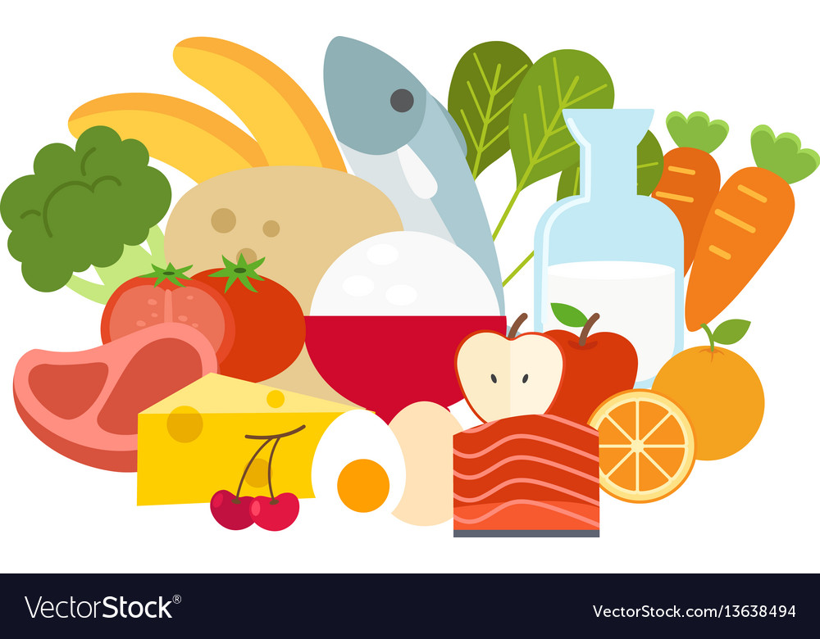

*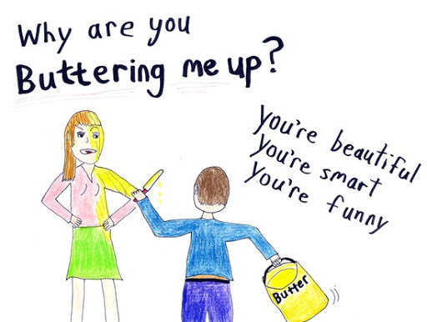*

***IDIOMS OF THE WEEK***

*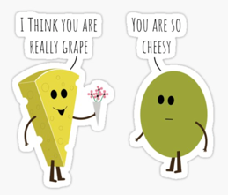*

**

***T1***

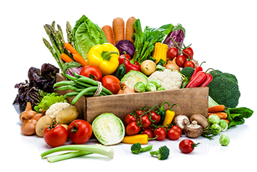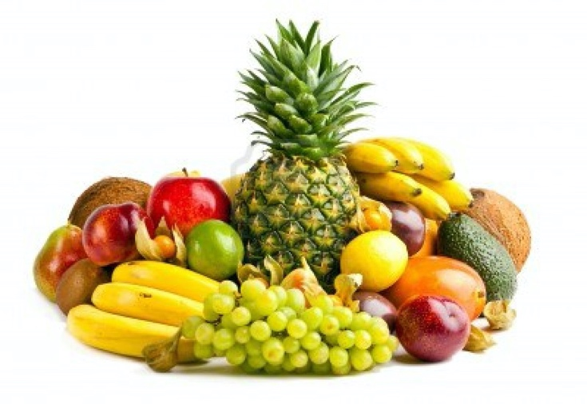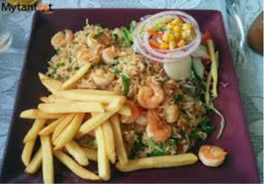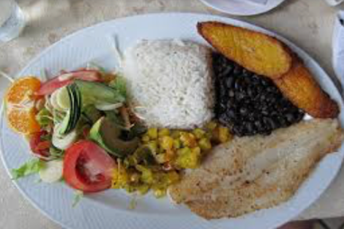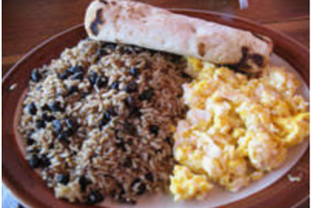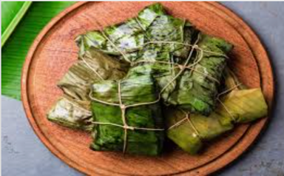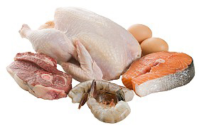

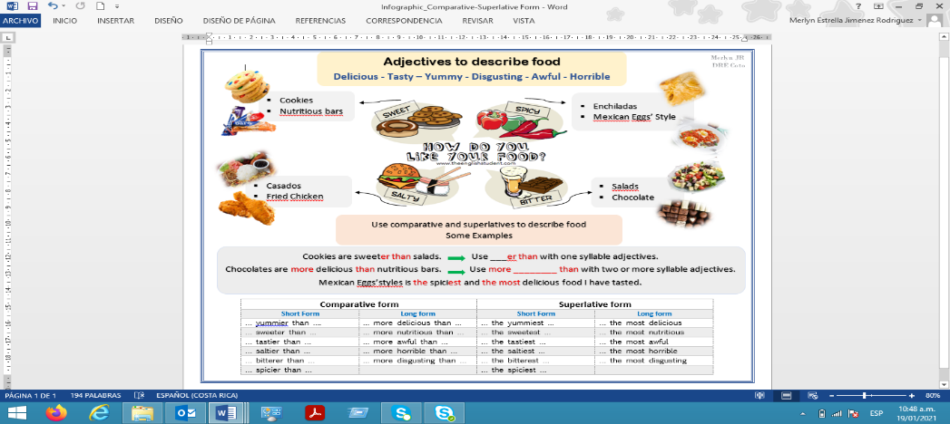

**ANNEXES**

***PROMPTS***

My favorite food*/meal* is …..

My prefered foods are …

I like … They are \_\_\_\_\_\_\_-er than …..

Fruits are better than candies.

\_\_\_\_\_\_\_\_\_\_ is \_\_\_\_\_\_\_\_er than \_\_\_\_\_\_.

\_\_\_\_\_\_\_ is more \_\_\_\_\_ than \_\_\_\_\_\_\_\_\_.

Carrots are the yummiest of the vegetables.

Chicken is better than pork meat.

\_\_\_\_\_\_\_ are the \_\_\_\_\_\_\_-est \_\_\_\_\_\_\_\_\_\_\_\_\_\_\_\_.

\_\_\_\_\_\_\_\_\_ are the most \_\_\_\_\_\_\_\_\_\_\_\_ food.

Vegetables are the most nutritious food.

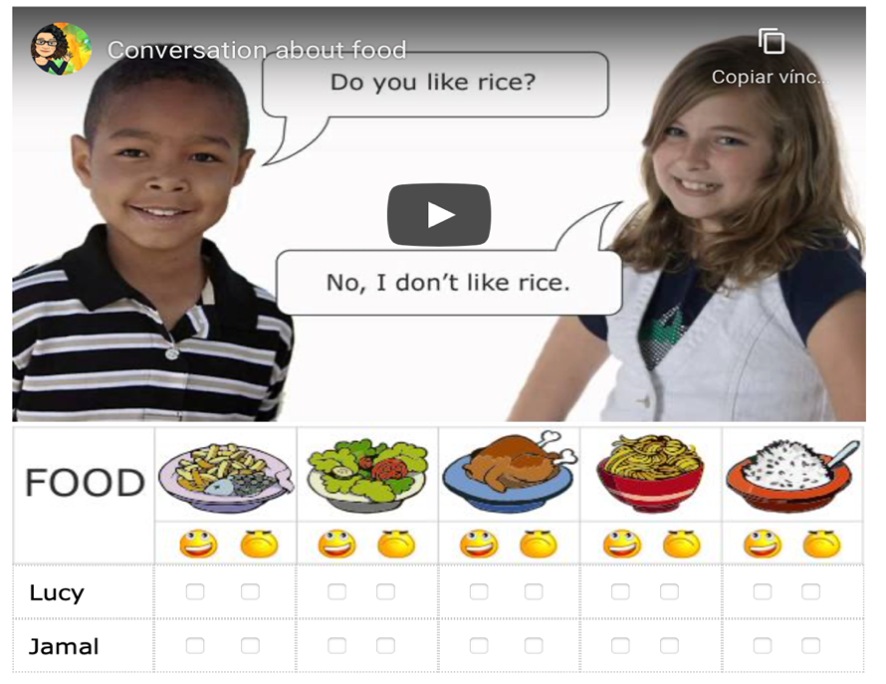

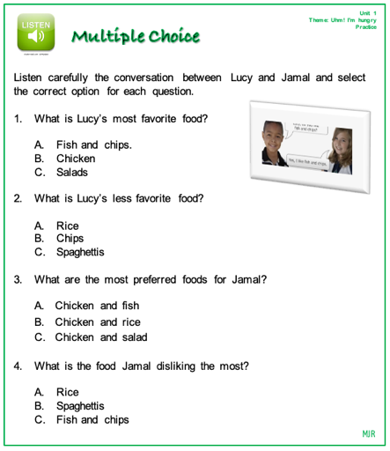**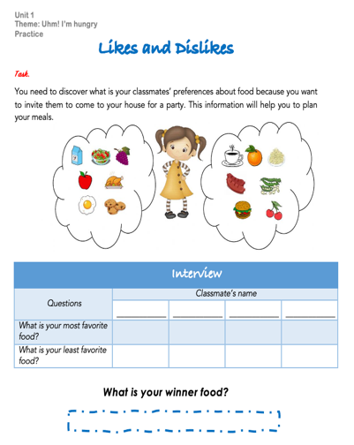**

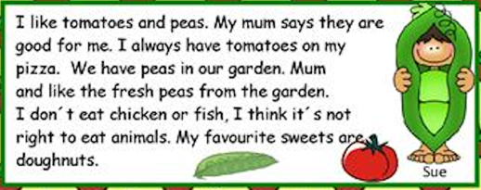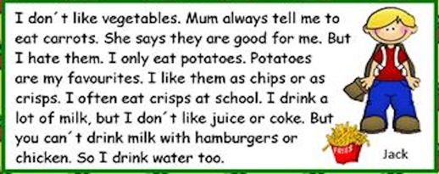

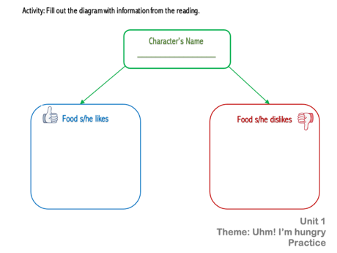

|  |  |  |  |
| --- | --- | --- | --- |
|  | Food S/he  likes | Food S/he  dislikes | Is it healthy or unhealthy? |
| SUE |  |  |  |
| JACK |  |  |  |
| WILLIAM |  |  |  |
| BRENDA |  |  |  |

|  |  |  |  |  |  |
| --- | --- | --- | --- | --- | --- |
| **Term:** | **Level: Fifth Grade** | | **Unit: 4** | | **Week:2** |
| **Domain: Socio-interpersonal:** Socio-interpersonal | | **Scenario: Healthy Choices, Better Life** | | **Theme:**  What did You Cook? | |
| Almost every day, we do things like count, measure, estimate, and calculate to get things done. We use numbers in sports and shopping. These actions help us be more confident in our decisions and they help us communicate our needs. | | | | | |
| **Essential Question:**  How do we quantify our world every day to lead better lives? | | | | | |
| |  | | --- | | **Dimensions** | | **1.** **Ways of thinking (   )** | | **2. Ways of living in the world  ( )** | | **3. Ways of relating with others  ( )** | | **4. Tools for integrating with the world  ( )** | | | | | | |
| **Learn to Know** | | **Learn to Do** | | **Learn to Be and Live in Community** | |
| **Grammar & Sentence Frames**  *Past simple:* They cooked …/ I mixed…/I prepared...  *WH questions*: How did you prepare it?  *Prepositional phrases:*   * The food is on the table. * The ingredients are on the counter. * Place the pot on the stove.   **Phonemic Awareness**  Reading regularly spelled two-syllable and compound words including consonant blends. (**bl, st, and tr**)  **Vocabulary**  *Recipes and more**Expressions and phrases*   * What a delicious meal! * How did you prepare it?   *Quantities and amounts:* a little, a lot, a kilo, a bottle, a bar, a tin/can  *Sequence words:* First, second, then, finally  *Verbs*: Boil, grill, bake… | | **Function**  Describing procedures for quantifying items  **Discourse Markers**  Sequence adverbs-past tense  First, next, then, finally | | **Psycho-social**  Respecting other people’s customs and habits  **Socio-cultural**  Sharing different lifestyles  **idioms/ phrases**  Cool as a cucumber (very relaxed) | |

|  |  |  |  |
| --- | --- | --- | --- |
| **Assessment Strategies & Evidences of learning**  (Diagnostic, formative, summative) | **Goals** | **Pedagogical Mediation/ Didactic Sequence** | **Time** |
| Learner… | Learner can | ***CONNECTION***  **Pre-teaching**  *The teacher sets the classroom, leads the routine and quickly checks the attendance. Then T announces the beginning of the new topic. Creative teachers can display a chart with the essential question enduring understanding and theme besides the idiom they will learn during this week or any other creative idea.*  **Warm up**  Ss and teacher sing the song “***What’s your favorite food?***” <https://www.youtube.com/watch?v=tlugFP6lzuM> After singing the song the teacher asks Ss what is their favorite food. Ts can make puppets or flash cards for students to use while singing according to what they hear in the song.  **Activation of Prior Knowledge**  To activate the prior knowledge, the teacher asks the learners the following questions:   * What is your favorite food? I like… * What is your least favorite food? … * What is the healthiest food that you like to eat?... * What did you eat for breakfast this morning? * How did you prepare it?   **Modeling**  Then the teacher introduces the past tense form of some regular verbs and their pronunciation according to the final sound in each one /id/, /d/, /t/. The video is found in this link <https://youtu.be/VFGSauN2Dbs>  Ss are asked to repeat the pronunciation of the cooking verbs focusing their attention in the ending sounds.  Now the teacher projects (PPT) or pastes two charts, one of them with a short recipe, and the other one with quantities and amounts used for cooks and chefs when cooking.    The teacher asks learners to read the recipe aloud after him/her. Then, s/he tells them to pay attention to the different elements used to make recipes and points out the parts for the students to see it. The teacher tells students that sometimes we use numbers to quantify ingredients but also, we use **some** to mean a small amount of ingredients like butter.  **Clarifying**  The teacher asks students to identify the following words in the recipe:   1. Sequencers 2. Past tense verbs 3. Quantities and amounts     Learners attempt to retell the recipe with the help of the matching activity. | ‘5  ‘5  ‘5  ‘10  ‘5  ‘5  ‘5 |
| **L.2.** recognizes short, clear, and simple instructions and explanations when delivered slowly (e.g., first, you add... then, you mix...).  **L.2.1.** gets the gist of short clear simple instructions about being healthy when delivered slowly. (e.g., first... then... besides…) by answering questions.  **L.2.2**. recognizes short, clear, and simple instructions about being healthy when delivered slowly (e.g., first, you add... then, you mix...) by sequencing a set of sentences or pictures.  **L.2.3.** gets the gist of short clear simple explanations about food when delivered slowly. (e.g., first... then... besides…) by answering questions.  **L.2.4**. recognizes short, clear, and simple explanations about preparing food when delivered slowly (e.g., first, you add... then, you mix...) by sequencing a set of sentences or pictures. | **L.2.** understand short, clear, and simple instructions and explanations when delivered slowly (e.g., first, you add... then, you mix...). | ***CONNECTION***  **Pre-task**  Teacher introduces the goal for the lesson.  T asks Ss if they have tasted “Guacamole” and then asks Ss if they know how to prepare it. Ss brainstorm the ingredients and possible steps to prepare it. T writes on the board students’ ideas. Then T underlines on the board the ingredients required for the recipe and the possible steps.    ***CLARIFICATION***  **Task-rehearsal**  *Listening for the first time:* T then projects the video ***“Children make Guacamole”*** <https://www.youtube.com/watch?v=Lm_dtIGRSzI>**;** while watching the video, students tick ingredients, verbs and steps (prepositional phrases) they hear from a list provided by the teacher.  *Teacher’s and pair-group & feedback:* Ss in pair, check their work with their classmates and the teacher asks the group specific information, for instance;   1. What ingredients did you hear from the video? 2. What steps did you hear from the video? 3. What phrases did you hear from the video? 4. What steps did not belong to the list?   *Self-assessment:* Ss individually asses their achievement.   |  |  |  | | --- | --- | --- | | I remembered | YES | NO | | … only a word/steps. |  |  | | … some steps. |  |  | | … all the steps. |  |  |   ***COSTRUCTION & APPLICATION***  **Task completion**  *Listening for the second time:*  Ss watch the video and answer these general questions:   1. Did the recipe mention amounts? 2. Did the recipe include baking an ingredient?   Ss get in pairs and compare their responses and check them.    Ss are given a worksheet and listen to the video a third time and sequence in more detail the explanations provided to prepare the scallions and the tomatoes.  ***COLLABORATION***  **Task assessment**  T sticks a set of pictures of the recipe on the board and both, T and Ss, will check the correct sequence of steps according to what they watch on the video. See the images in annexes. | 40 minutes |
| **R2.** Recognizes much of what is written in short, simple texts on subjects with which they are familiar and/or in which they are interested.  **R2.1** Recognizes much of what is written in short, simple recipes with which they are familiar.  **R2.2** Recognizes much of what is written in short, simple text at using sequencers and past form of verbs with which they are familiarized. | **R2.** understand much of what is written in short, simple texts on subjects with which they are familiar and/or in which they are interested. | ***CONNECTION***  **Pre-task**  Ss get familiar with the goal of the lesson.  T brainstorm fruits Ss already know in English and ask them to write their names on the board.  Then the T ask the students if they have prepared a fruit salad before and brainstorms some steps students might know.  ***CLARIFICATION***  **Task-rehearsal**  Ss work in pairs to *read* a recipe *for the first time*. They should underline in red color all the words they know from the recipe and using blue color for the new words. Then Ss briefly check their words with their classmates and will receive feedback from their peers.    ***COSTRUCTION & APPLICATION***  **Task completion**  Ss discuss in groups of four, the steps of the recipe “**Fruit Salad”.** They should find the correct sequence of the steps to prepare the fruit salad. Then they will compare their sequence with other groups. Teacher will monitor this collaborative work and provide feedback.  **Task assessment**  After, they find the right order of the steps, they will rewrite the sequence using the adverbs of frequency and verbs in past tense. The teacher will project the ppt about verbs ending in -ed for students to get help in this activity.  <https://youtu.be/VFGSauN2Dbs> | 40 minutes |
| **SP.1.** Describes their favorite recipe, how to prepare it, and possible length of time and nutritious value.  **SP.1.1**. brainstorms the ingredients of a favorite recipe using phrases and sentences supported with pictures.  **SP.1.2.** identifies nutritional value of ingredients of favorite recipe using phrases and sentences supported with pictures in an oral interaction.  **SP.1.3.** uses appropriate vocabulary, phrases and sentences to describe cooking steps in an oral exchange.  **SP. 1.4.** uses sequence adverbs when explaining how to prepare favorite recipe. (first, second, third, next, finally) | **SP.1.** describe their favorite recipe, how to prepare it, and possible length of time and nutritious value. | ***CONNECTION***  **Pre-task**  Ss get familiar with the goal of the lesson.  The teacher posts the following chart on the board and explains the Ss how the different food’s groups provide our bodies with minerals, vitamins, carbohydrates and proteins needed to grow healthy and strong.    After this introduction, the teacher tells the Ss they should work in groups 3 and brainstorm phrases and high frequency words they are going to use later to make their own recipes. S/he gives them the time to organize the groups.  The teacher explains to learners the task in which they are going to work.  **Task:** Your community is organizing a food contest for kids as part of a fair to collect money for the community projects. The contest consists of preparing three dishes for breakfast, lunch or dinner, for example, one entrée, one main dish and dessert or drink. All the food/plates are going to be sold. You and your friends registered in the contest. The organizers announced the following requirements for the teams that want to participate.   1. Use local and natural products (fruits, vegetables, meats and grains) 2. List the ingredients that you used. 3. Describe the steps you followed to prepare the recipe, include the sequencers to explain the steps and two or three quantities or amounts. 4. Mention the nutritional value of your dish. 5. Mention the length of preparation. 6. Attention to the pronunciation of past tense verbs is important. 7. Every group member will be in charge of presenting one dish.   ***CLARIFICATION***  **Task-rehearsal**  Ss get together and start planning the dishes they want to prepare. They brainstorm names of dishes; their ingredients, quantities or amounts, cooking procedures and sentences frames and vocabulary need it to describe their dishes.  Later, students do research about the nutritional value of each of the dishes and cooking time, they can ask their grandmother and mothers or people in the community.  After they have their dishes ready, they rehearse to present their recipes to the jury.  After the groups have seen the different dishes through a **gallery walk**, all the groups have the opportunity to check other’s groups recipes and provide feedback to their peers.  ***COSTRUCTION & APPLICATION***  **Task completion**  Once they finished the gallery walk, they will start presenting their dishes to the jury (teacher and other teams).  ***COLLABORATION***  **Task assessment**  Teacher and teams are going to evaluate the presentation using a simple instrument for co-assessment.   |  |  |  | | --- | --- | --- | | Co-assessment Instrument  The team … | YES | NO | | used local and natural products (fruits, vegetables, meats and grains) |  |  | | listed the ingredients to be used |  |  | | described the steps to prepare the recipe. |  |  | | mentioned the nutritional value of the recipe/dish. |  |  | | mentioned the length of preparation. |  |  | | said the past tense verbs endings correctly. |  |  | | distributed appropriately the roles of their participants. |  |  |     The winners will get the recognition of **“Healthy Cook of the Year”** | 40 minutes |
| **PA.1.** Shows knowledge of phonemic awareness by reading consonant blends (bl, st, and tr)  **PA.1.1** Identifies consonant blends (bl, st, tr).  **PA.1.2** Reads consonant blends (bl, st, tr). | **PA1.** demonstrate knowledge of phonemic awareness. | ***CONNECTION***  **Pre-task**  Ss get familiar with the goal of the lesson.  The teacher announces they will do a review of the consonant blends they studied the week before.  So that they will review the video in this link, or use the QR Code  <https://acortar.link/C1WXS> ´    After students watch the video, the teacher introduces the new words with the blends. This time the teacher is going to show only the images.  The teacher asks the students to watch the images and asks the Ss if they recognize any of the pictures. Then Ss start brainstorming words, S/he writes the words down on the board. Once Ss have recognized most of the words, teacher underlines the consonant blends in study.  ***CLARIFICATION***  **Task-rehearsal**  egosauros  St    Teacher splits the group into five small groups and gives them an envelope with a set of paper strips containing some strips with the consonant blends, and some strips with the words without the initial consonants. Ss should form words using the consonant blends.  ***COLLABORATION***  At the end of the activity, the groups will rotate to check other’s group words. The group whose first form more correct words is the winner.  ***COSTRUCTION & APPLICATION***  **Task completion**  The Ss work in a small project to design a spin wheel with the consonant blend and words they have studied in the previous activity.  The teacher helps and monitors students’ progress in the small project. When they finish, start playing with the wheel. They form words and read it for themselves.  **Task assessment**  Ss come in front of the class and spin their wheels and say the word they formed aloud. The rest of the class checks the meaning of the word and the pronunciation of the blends as well as the whole word. If the word is correct, the group will show their thumps up. | 40 minutes |

|  |  |  |  |
| --- | --- | --- | --- |
| **Integrated Mini-Project** | | | **Time** |
| Phase: \_\_\_\_\_\_\_ | | |  |
| **Reflective Teaching** | | | |
| What worked well | What didn’t work well | How to improve | |
| **Enduring Understanding Reflection** | | | |
|  | | | |

|  |  |  |  |
| --- | --- | --- | --- |
| Learner self-assessment | | | |
| I can … | Yes | Sort of | No. Help! |
| L.2.1. gets the gist of short clear simple instructions about being healthy when delivered slowly. (e.g., first... then... besides…) by answering questions. |  |  |  |
| L.2.2. recognizes short, clear, and simple instructions about being healthy when delivered slowly (e.g., first, you add... then, you mix...) by sequencing a set of sentences or pictures |  |  |  |
| L.2.3. gets the gist of short clear simple explanations about food when delivered slowly. (e.g., first... then... besides…) by answering questions. |  |  |  |
| L.2.4. recognizes short, clear, and simple explanations about preparing food when delivered slowly (e.g., first, you add... then, you mix...) by sequencing a set of sentences or pictures. |  |  |  |
| R2.1Recognizes much of what is written in short, simple recipes with which they are familiar. |  |  |  |
| R2.2 Recognizes much of what is written in short, simple text at using sequencers and past form of verbs with which they are familiarized. |  |  |  |
| SP.1.1. brainstorms the ingredients of a favorite recipe using phrases and sentences supported with pictures. |  |  |  |
| SP.1.2. identifies nutritional value of ingredients of favorite recipe using phrases and sentences supported with pictures in an oral interaction. |  |  |  |
| SP.1.3. uses appropriate vocabulary, phrases and sentences to describe cooking steps in an oral exchange. |  |  |  |
| SP.1.4. uses sequence adverbs when explaining how to prepare favorite recipe. (first, second, third, next, finally) |  |  |  |
| PA.1. Shows knowledge of phonemic awareness by reading consonant blends (bl, st, and tr) |  |  |  |
| PA.1.1 Identifies consonant blends (bl, st, tr). |  |  |  |
| PA.1.2 Reads consonant blends (bl, st, tr). |  |  |  |

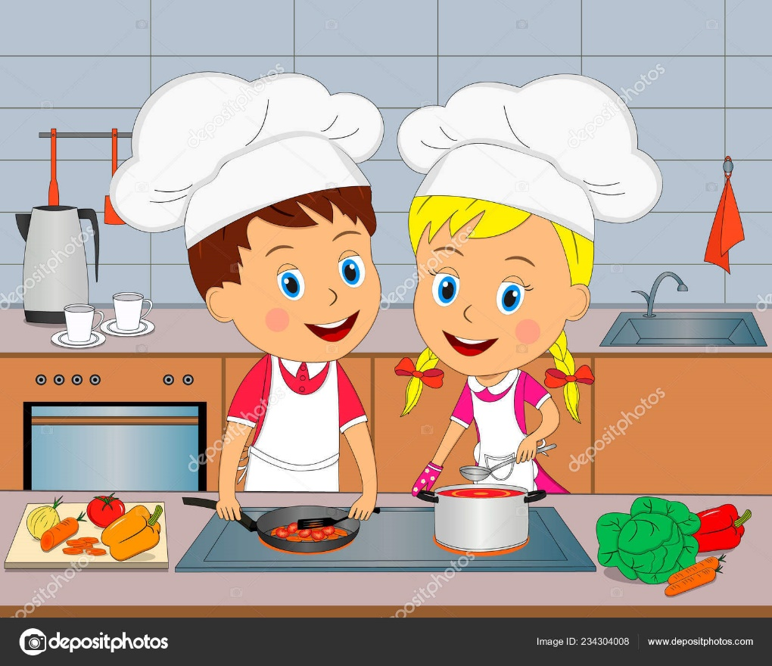

**Theme 2 Resources**

**What Did You Cook?**

**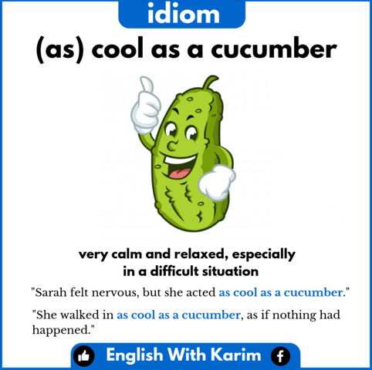**

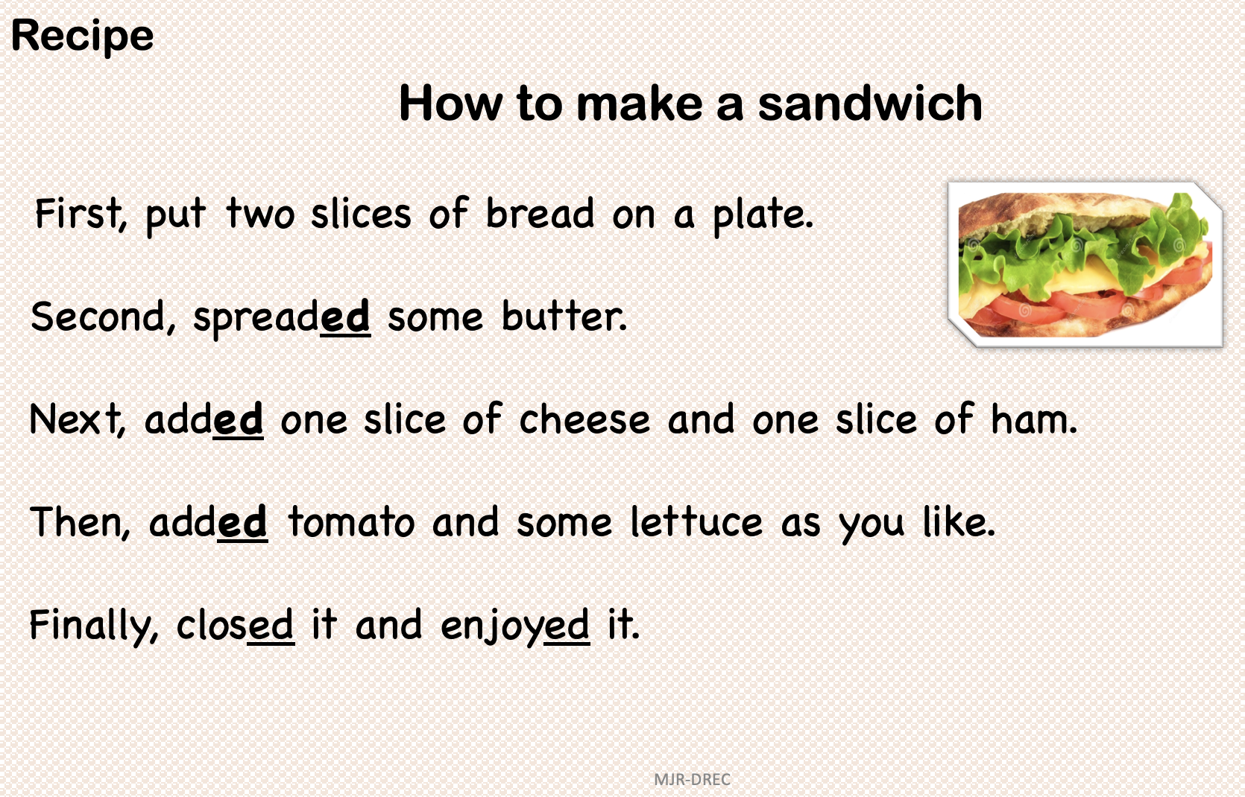

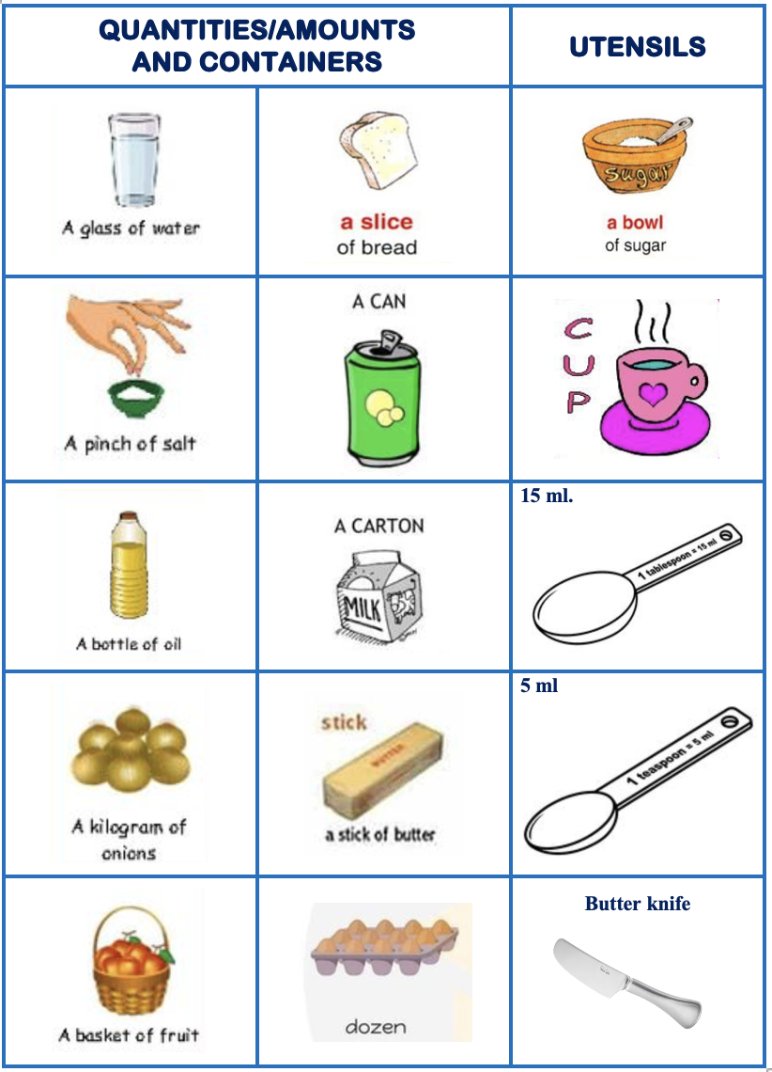

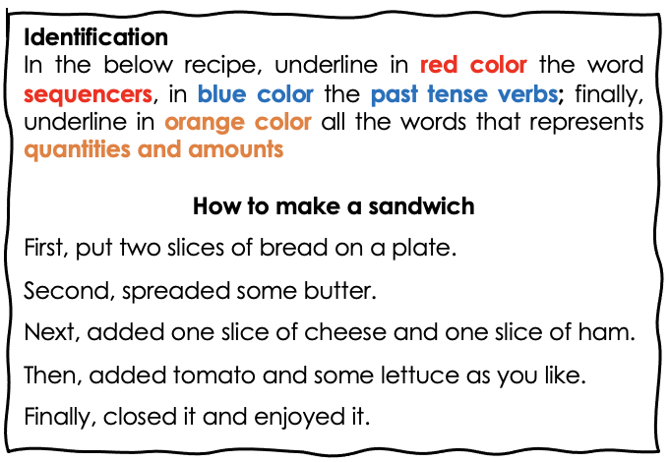

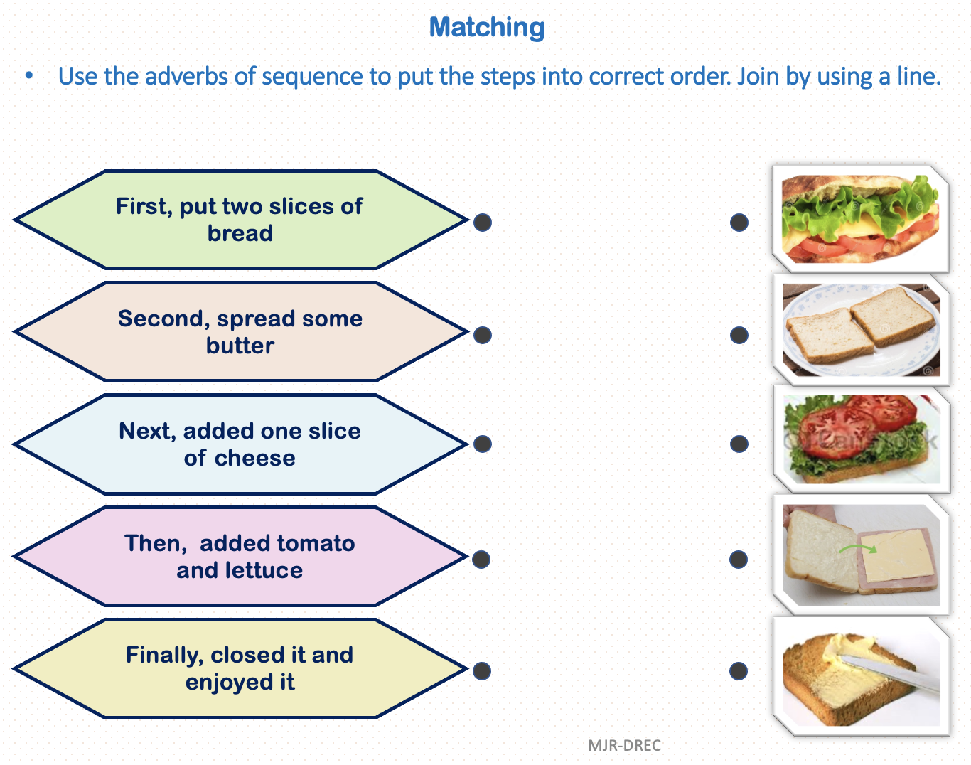

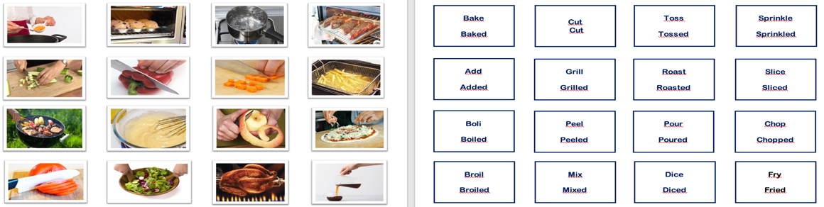

**Flashcards - Verbs**

Additional material

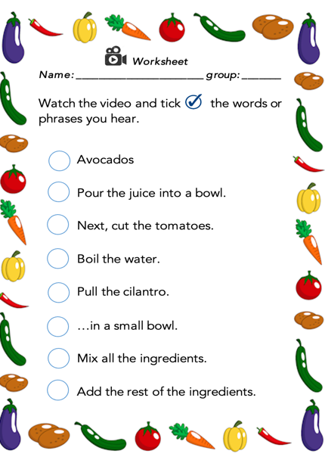

**Worksheet**

**Worksheet**

**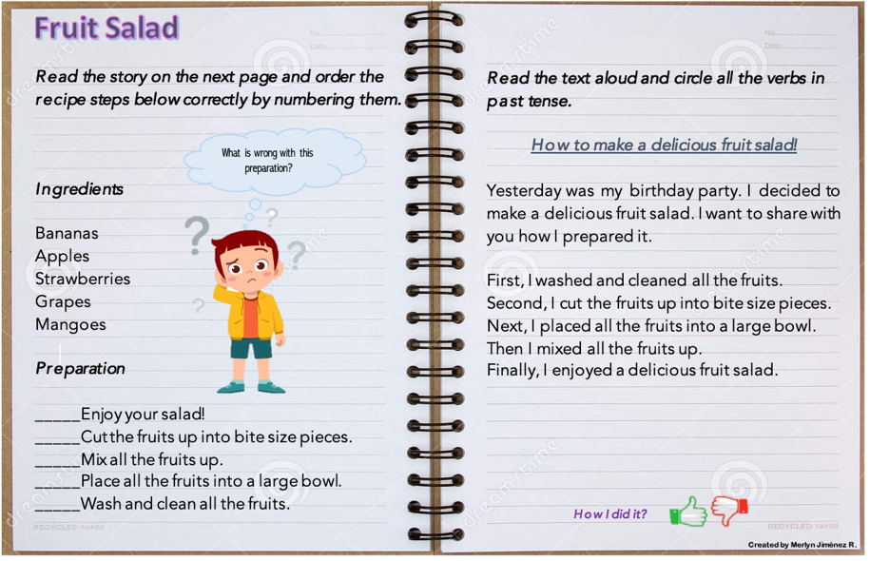**

**Worksheet**

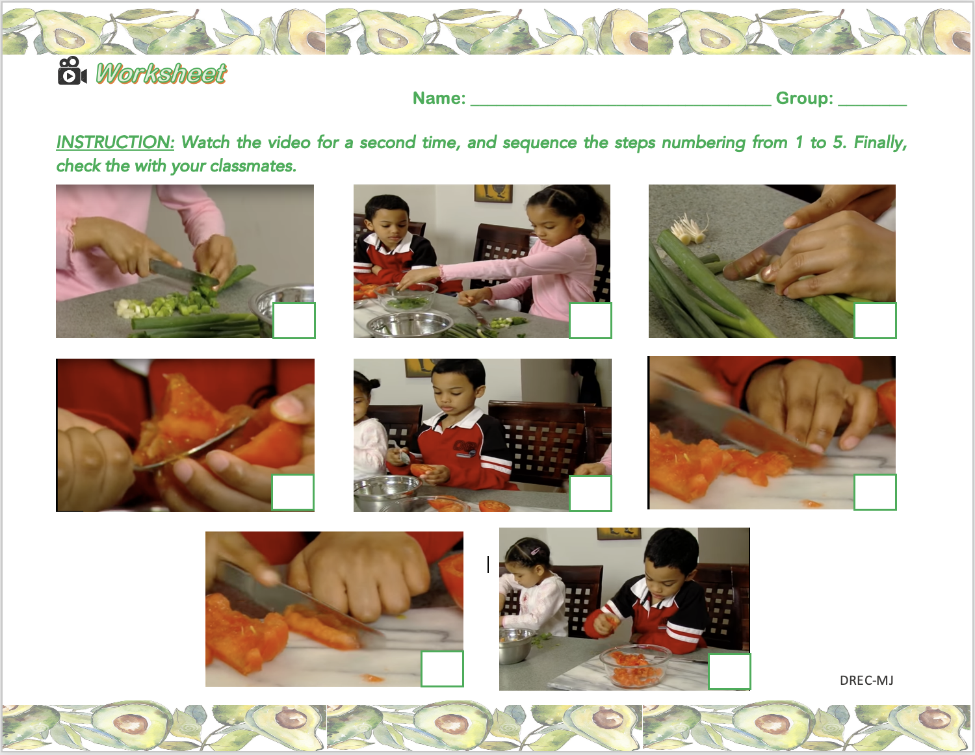

**Flashcards**

**Flashcarts**

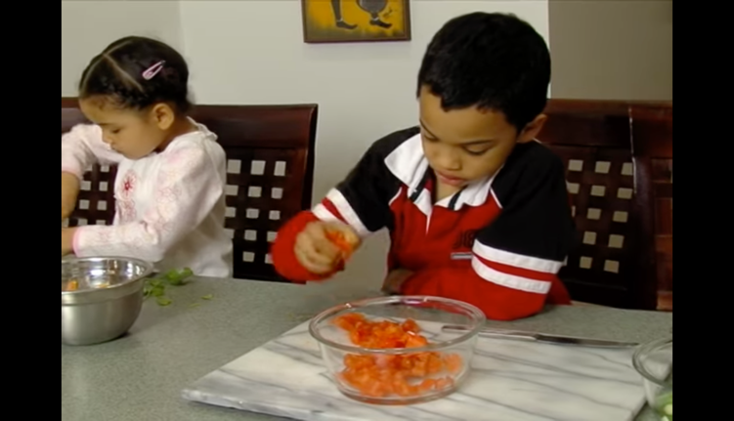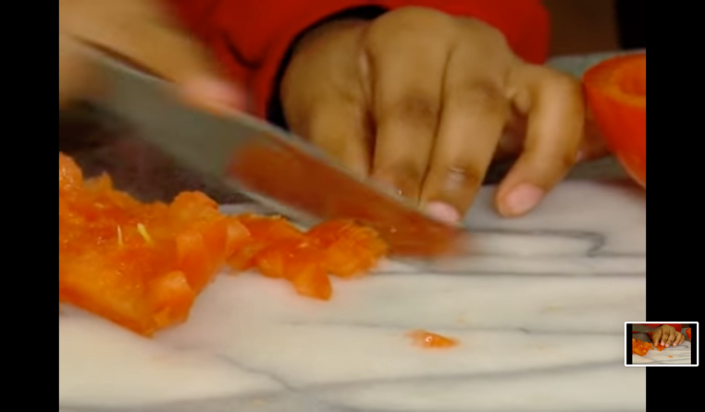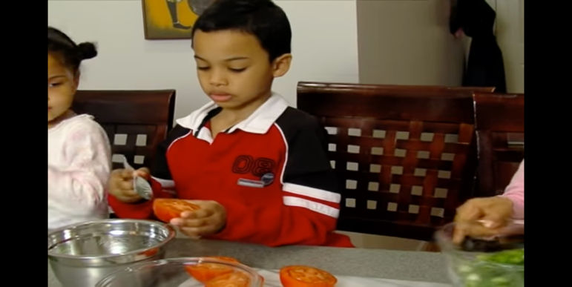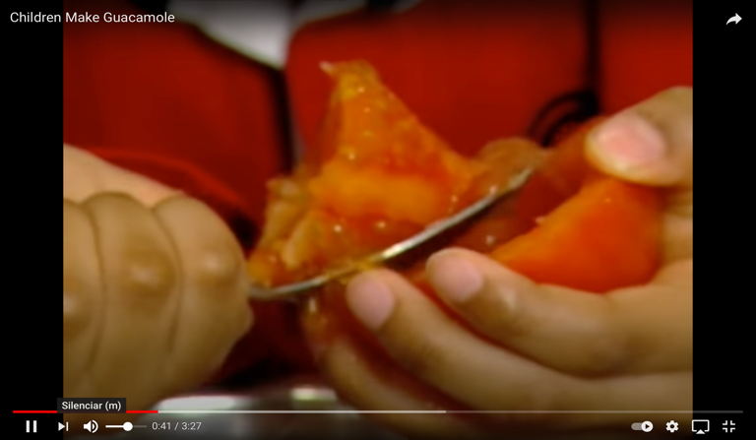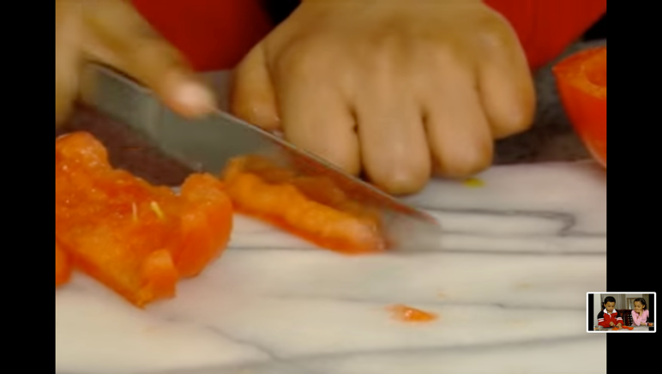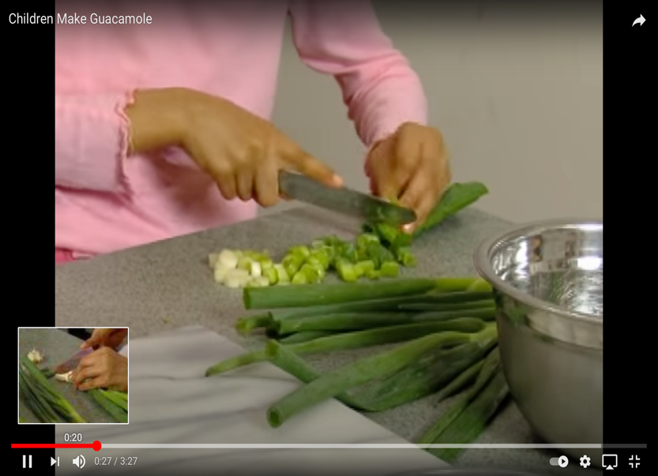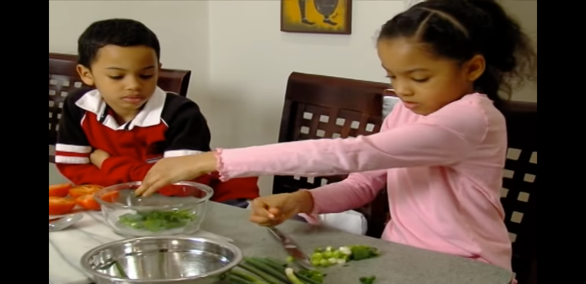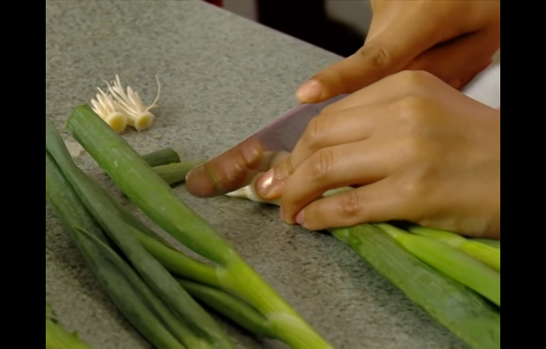

Legumes and grains are low in fat and cholesterol.

Grains contain fiber that is good for your body.

Legumes and grains are rich minerals.

Grains and legumes have antioxidants that are good for your skin.

Grains are mostly made up of carbs.

Nutritional Value of Food for Balancing Diets and Menus

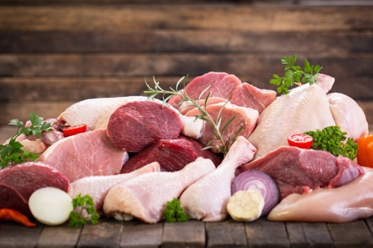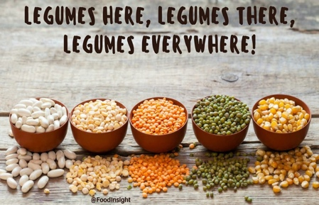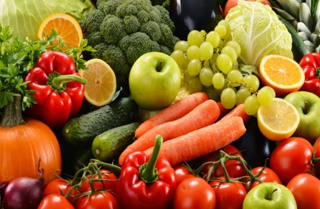

Fruits contain many vitamins.

Fruits are rich in minerals that are good for your health.

Vegetables are rich in vitamins and minerals.

Meat is an excellent source of many nutrients.

Meats especially have proteins and B vitamins,

You can get a good source of iron and zinc in meats.

**Chart**

**Game**

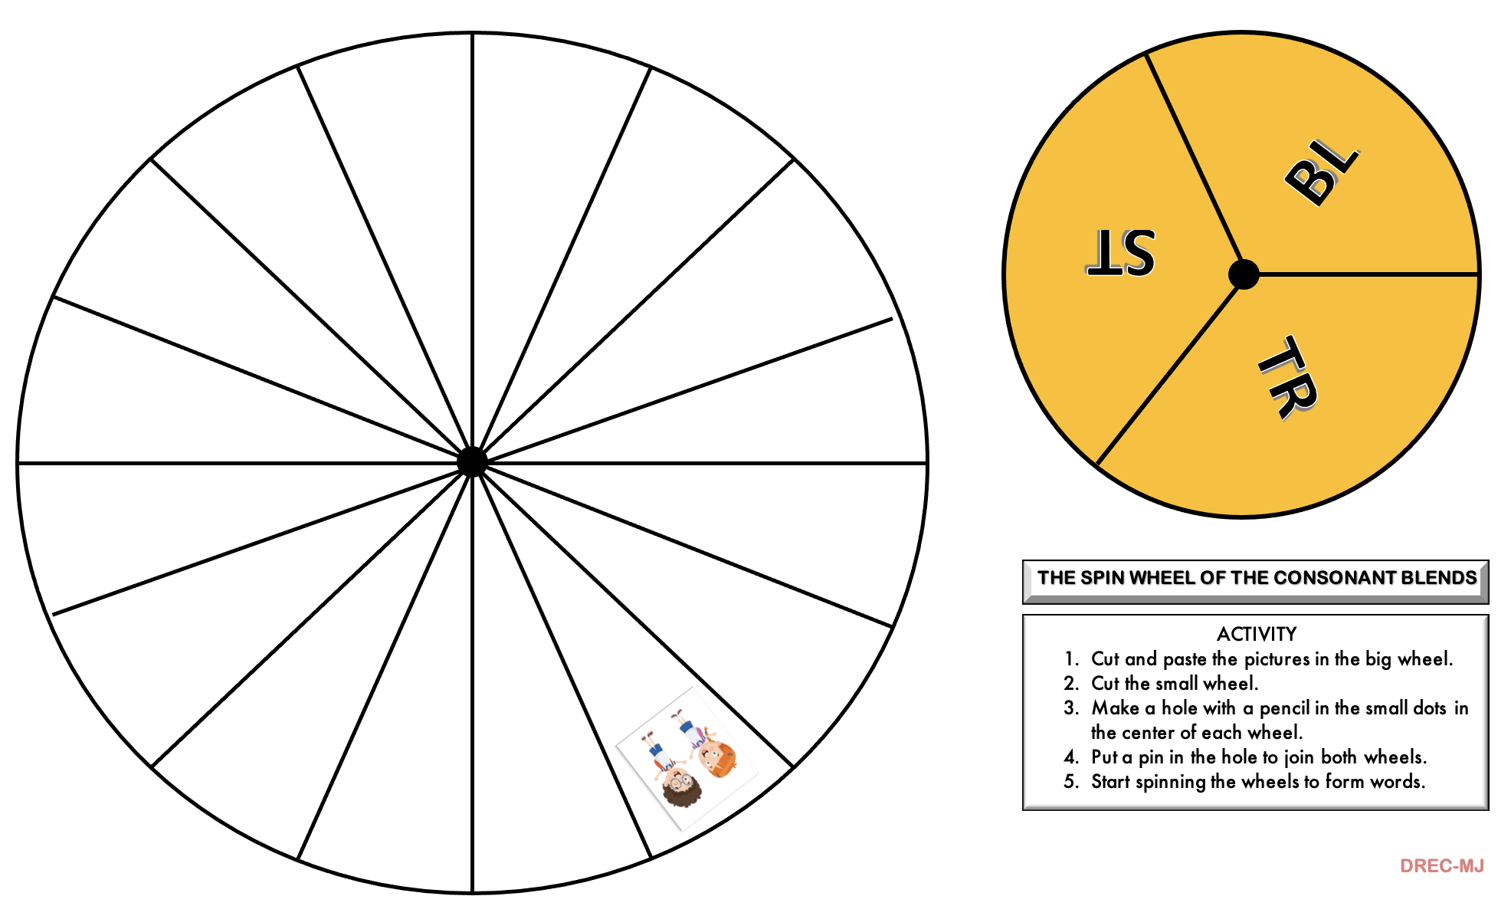

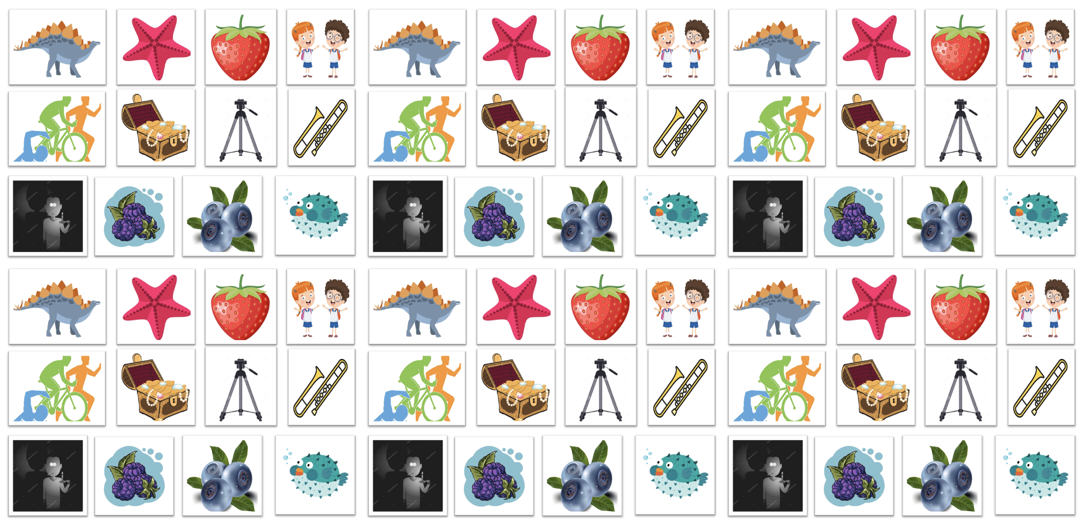

|  |  |  |  |  |  |
| --- | --- | --- | --- | --- | --- |
| **Term:** | **Level: Fifth Grade** | | **Unit: 4** | | **Week:3** |
| **Domain: Socio-interpersonal:** Socio-interpersonal | | **Scenario: Healthy Choices, Better Life** | | 1. **Theme:**  Let´s Stay in Shape | |
| **Enduring Understanding:** Almost every day, we do things like count, measure, estimate, and calculate to get things done. We use numbers in sports and shopping. These actions help us be more confident in our decisions and they help us communicate our needs. | | | | | |
| **Essential Question:**  How do we quantify our world every day to lead better lives? | | | | | |
| |  | | --- | | **Dimensions** | | **1.** **Ways of thinking (x)** | | **2. Ways of living in the world (x)** | | **3. Ways of relating with others  ( )** | | **4. Tools for integrating with the world  ( )** | | | | | | |
| **Learn to Know** | | **Learn to Do** | | **Learn to Be and Live in Community** | |
| **Grammar & Sentence Frames**  Future with will   * I am overweight so I will go on a diet. * I will eat healthy food.   Comparative and superlative adjectives.   * Running is better than walking. * Running is the best exercise.   WH questions   * How often do you do exercise?   **Phonemic Awareness**  Practicing minimal pair sounds:  /-t / heart, plate, bet, bought  /-d/ hard, played, bed, bored  **Vocabulary**  Let´s keep in shape  Expressions and phrases   * What are you doing to keep in good shape? * Where are you going after school? I’m going to ride my bike. * What are you eating for dinner? * Let’s practice sports.   Activities   * Going to the gym * Playing soccer with my friends * Eating healthy food. * Running in the park. * Swimming in the river/swimming pool | | **Function**  Describing habits and routines  **Discourse Markers**  Sequence adverbs-past tense  First, next, then, finally | | **Psycho-social**  Leading a healthy life  **Socio-cultural**  Promoting healthy food and healthy habits  **idioms/ phrases**  Full of beans (lively, active and healthy) | |

|  |  |  |  |
| --- | --- | --- | --- |
| **Assessment Strategies & Evidences of learning**  (Diagnostic, formative, summative) | **Goals** | **Pedagogical Mediation/ Didactic Sequence** | **Time** |
| Learner… | Learner can | ***CONNECTION***  **Pre-teaching**  *Teacher sets the classroom, leads the routine and quickly checks the attendance. Then T announces the beginning of the new topic. Creative teachers can display a chart with the enduring understanding, essential question, theme and the idioms they will learn during this week or any other creative idea.*  **Warm up**  T invites students to sing and act out the song “**I can move my body like anything”.**  <https://www.youtube.com/watch?v=oLaJ4jyKBUY>  After Ss do the activity, the teacher asks them **¿Are you full of beans right now?**  **Activation of Prior Knowledge**  After Ss get some fun singing and acting out the song, teacher brainstorm with them some healthy food and activities and habits to keep healthy.  Then T starts speaking about staying in shape with the help of healthy eating habits and exercising regularly. S/he presents a video for students to observe ***what humans need to stay healthy.***  <https://www.youtube.com/watch?v=UxnEuj1c0sw>  Before the video is presented, Teacher chooses some of the phrases from the chart below and writes them on the board and read them with the help of Ss; those phrases come from the video. Once students observe the video, T asks Ss what phrases they hear in the video and underline them.  feel good - helps to live longer - do more fun activities  eat a good balance of all healthy food - need plenty of sleep  have plenty of fresh vegetables and fruits  drinks lots of water - do lots of exercise - good hygiene  make your body stronger and better - wash your hands before you eat  **Modeling**  The teacher is going to talk about her/his plan to be healthier and then the teacher will use her/his own example to introduce vocabulary and sentence frames needed to talk about how to be healthy.  ***Situation***  …I went to the doctor yesterday and the doctor told me I am overweighted and I need to make changes in my habits to be healthier. So, I will do few changes, for example:   1. I will go on a diet. 2. I will exercise 30 minutes per day. 3. I will drink more water. 4. I will …. 5. I will not ….   ***CLARIFICATION***  **Clarifying**  Teacher tells students they will do a short survey to their classmates using the following question: **What will you do to be healthier**? Responding with **I will…** | 40 minutes |

|  |  |  |  |  |  |  |  |  |  |  |  |  |  |  |  |  |  |  |  |  |  |  |  |  |  |  |  |  |  |  |  |
| --- | --- | --- | --- | --- | --- | --- | --- | --- | --- | --- | --- | --- | --- | --- | --- | --- | --- | --- | --- | --- | --- | --- | --- | --- | --- | --- | --- | --- | --- | --- | --- |
| **SI.1.** states single step directions/ commands using words and phrases.  **SI.1.1** Discusses single steps/commands about how to stay healthy using words and phrases in a pair or group interaction.  **SI.1.2** States single step directions/commands about how to say healthy using words and phrases in a pair or group interaction. | **SI.1.** state single step directions/ commands using words and phrases. | | ***CONNECTION***  **Pre-task**  Ss get familiar with the goal of the lesson.  T asks learners what activities and habits their parents have taught them at home and write their responses on the boards.  T shows a set of activities, habits and questions to have a healthy life style. Then s/he asks them to read it aloud.   |  |  | | --- | --- | | ACTIVITIES | HABITS | | Go to the gym.  Play soccer with my friends.  Run in the park.  Swim in the river/pool.  Walk everyday 30 minutes. | Drink more water.  Eat healthy food.  Sleep eight hours.  Always eat breakfast.  Turn off TVs or cellphones early. |   **QUESTIONS**  What are you going to do to stay healthy? I’m going to …  What are you doing to keep in good shape? I’m doing …  What are you eating for dinner? I am eating more ….  What will you do to keep in good shape? I will …  Where are you going after school? I’m going to  T takes advantage of the questions to tell Ss how to answer the questions with **“going to”** and **“will”**  **ADVERB SEQUENCE**  First, Second, Then, Next, Finally  ***CLARIFICATION***  **Task-rehearsal**  Ss solve the situation presented in the task below:  **TASK**  The doctor suggested that you need to make changes to improve your health. In the chart below there are some activities and healthy habits that could help you achieve your goal. Decide which activities and habits you will include in your daily routine.  Include at least four actions you will do using first, second, third, and finally.  Share with a partner your choices asking and responding to the questions: “What will you do to be healthy? What are you going to eat to stay healthy?”   |  |  | | --- | --- | | ACTIVITIES | HABITS | | Go to the gym.  Play soccer with my friends.  Run in the park.  Swim in the river/pool.  Walk everyday 30 minutes. | Drink more water.  Eat healthy food.  Sleep eight hours.  Always eat breakfast.  Turn off TVs or cellphones early. |   ***COSTRUCTION & APPLICATION***  **Task completion**  **TASK**  Your father went to the doctor yesterday, she told him that he has extra-weight and high blood pressure. He needs to change eating habits among other things. You have to give advice to your father, what would you tell him to do to be healthier?   1. First, … 2. Second, … 3. Third, … 4. Finally, …   Make a role play with a partner, one will be the father and the other will be the son or daughter.  You can use questions like …   * What is wrong with you dad? * Do you have some advice for me?   ***COLLABORATION***  **Task assessment**  Ss evaluate themselves with a check list to visualize what elements of the new language they put into practice.   |  |  |  | | --- | --- | --- | | CHECK LIST | YES | NO | | Did I use words given in the topic? |  |  | | Did I use the phrases (commands) I study with my teacher and classmates? |  |  | | Did I use sentences that express future using “will”? |  |  | | Did I use questions with “going to”? |  |  | | Did I use sequencers in the conversation? |  |  | | | 40 minutes |
| **W1.** prepares simple reminders or notes for personal use (e.g., diary, journal, homework, book).  ***W1.1.*** identifies the main points to include in a personal note/reminder using an outline or mind map.  **W.1.2.** uses polite phrases and expressions when making a reminder such as: I wish to let you know, please, remember to… Just a friendly reminder, please do not forget… thank you… when writing a reminder.  **W.1.3.** writes a simple reminder and personal note to someone using sentence frames studied in class based on a prompt. | **W1.** prepare simple reminders or notes for personal use (e.g., diary, journal, homework, book). | | ***CONNECTION***  **Pre-task**  T shares the goal of the lesson  T asks students, **how do you feel?** **Are you full of beans this morning/afternoon/day**?  T pastes on the board a chart with short reminders to show Ss how to write reminders. Ss explore the messages and read them aloud with the help of the teacher.  Please, don’t forget to drink a lot of water!  Remember to call the doctor, please. Thank you!  Please, remember to eat your fruits!  Remind me to go to the gym, please!  Just a friendly reminder, food is ready.  I wish to let you know that you need to sleep well!  After s/he explains what is a ***short reminder***, teacher pastes two more notes in the board and asks students which is a reminder and which is not.   |  |  | | --- | --- | | Note 1 | Note 2 | | Please, remember to brush your teeth before going to bed. | Good bye! |   ***CLARIFICATION***  **Task-rehearsal**  Students read the following task:  **Task.**  Supposed you need to leave a short note/reminder in the refrigerator’ s door for your parents about the type of food they need to buy to follow the doctor’ s diet. Use good handwriting, polite expressions and punctuation.  Ss work in pairs and brainstorm ideas to write short and simple reminders collaboratively. They complete the following outline.  Recipient of the reminder:  Include polite a phrase/expression:  Include on the reminder types of food:  Include the type of action you want to remind:  ***COSTRUCTION & APPLICATION***  **Task completion**  Students using the information in the mind map or the outline elaborate a reminder based on the task given.  **Task.**  Supposed you need to leave a short note/reminder in the refrigerator’ s door for your parents about the type of food they need to buy to follow the doctor’ s diet. Use good handwriting, polite expressions and punctuation.  Let’s write a reminder  **Task assessment**  At the end of the task, Ss will paste their notes in a classroom book or mural. Then they will read the notes of others classmates to see the reminders they left for their parents.  ***COLLABORATION***  Finally, they participate in self-co assessment using this short rubric.   |  |  |  | | --- | --- | --- | | CHECK LIST | | | | I can | **YES** | **NO** | | identify the main points to include in a personal note/reminder using an outline or mind map. |  |  | | use polite phrases and expressions when making a reminder such as: I wish to let you know, please, remember to… Just a friendly reminder, please do not forget… thank you… when writing a reminder. |  |  | | write a simple reminder and personal note to someone using sentence frames studied in class based on a prompt. |  |  | | | 40 minutes |
| **PA.2.** Shows knowledge of phonemic awareness by pronouncing the sound /-t//-d/ at the end of words.  **PA.2.1**. identifies the pronunciation of endings /t/ and /d/ in regular past tense words when listening and when reading to sets of words and sentences.  **P.A.2.2**. produces the endings /t/ and /d/ when reading words and sentences that represent regular past tense verbs. | **PA.2.** Show knowledge of phonemic awareness by pronouncing the sound /-t//-d/ at the end of words. | | ***CONNECTION***  **Pre-task**  Ss get familiar with the goal of the lesson.  T pastes/projects on the board a chart with eight pictures with the ending sounds /t/ and /d/.  These words are minimal pairs. The teacher asks students to close their eyes and pay attention to each pair of words and be ready to say how these words are similar and different. T says the names of each pair of words at a time aloud. (**Words** **to** **read**: heart, hard: plate, played: bet, bed: bought, bored)  T asks Ss to sit down in pairs and talk about how similar and different the words are. Then, they share with all the group. T wraps up all ideas making emphasis on the difference between the final sounds of words.  ***CLARIFICATION***  **Task-rehearsal**  T shows them the pictures again, but this time they have a sentence with the word below. T reads the sentences and asks students to repeat.        ***COLLABORATION***  Ss get in pairs and practice reading the sentences paying special attention to the pronunciation of the bolded words.  T asks leaners to draw a simple table in their notebooks with 2 column and 8 rows. T will read one word at a time, and students have to write the final sound that they hear.   |  |  | | --- | --- | |  | /-t/ o /-d/ | | 1 |  | | 2 |  | | 3 |  | | 4 |  | | 5 |  | | 6 |  | | 7 |  | | 8 |  |   Ss exchange notebooks and check each other’s answers based on the teacher’s answers.  Ss get in pairs and practice the words paying more attention to any word that they missed in the previous exercise.  T asks Ss to work in pairs and gives them a set of flashcards with the words studied (T can use the pictures in previous exercises to make the cards). Student A will show a card to his/her pair and the pair will say the word aloud emphasizing the final sound /t/ or /d/. Then switch roles till practice all the words.  ***CONSTRUCTION & APPLICATION***  **Task completion**  Ss play a modified flyswatter game with the final sounds. Using the previous flashcards, Ss listen to the teacher read the words. They use a pen, pencil, ruler or any other item to hit the corresponding flashcard. T moves around the classroom quickly to see how the students do.  Design by MSc. Randall Centeno  **Task assessment**  T asks Ss to look for new words with the final sound /t/ or /d/ in different sources, with the help of their cellphones and internet, in English dictionaries, or in English books. Once they have chosen 1-2 words, they will write it/them on the board. Then, the whole group will read the words aloud emphasizing the final sounds. | | 40 minutes |
| **Integrated Mini-Project** | | | | | **Time** |
| Phase: \_\_\_\_\_\_\_ | | | | |  |
| **Reflective Teaching** | | | | | |
| What worked well | | What didn’t work well | | How to improve | |
| **Enduring Understanding Reflection** | | | | | |
|  | | | | | |

|  |  |  |  |
| --- | --- | --- | --- |
| Learner self-assessment | | | |
| I can … | Yes | Sort of | No. Help! |
| SI.1.1 Discusses single steps/commands about how to stay healthy using words and phrases in a pair or group interaction. |  |  |  |
| SI.1.2 States single step directions/commands about how to say healthy using words and phrases in a pair or group interaction. |  |  |  |
| W1.1. identifies the main points to include in a personal note/reminder using an outline or mind map. |  |  |  |
| W.1.2. uses polite phrases and expressions when making a reminder such as: I wish to let you know, please, remember to… Just a friendly reminder, please do not forget… thank you… when writing a reminder. |  |  |  |
| W.1.3. writes a simple reminder and personal note to someone using sentence frames studied in class based on a prompt. |  |  |  |
| PA.2.1. identifies the pronunciation of endings /t/ and /d/ in regular past tense words when listening and when reading to sets of words and sentences. |  |  |  |
| P.A.2.2. produces the endings /t/ and /d/ when reading words and sentences that represent regular past tense verbs. |  |  |  |

**Theme 3 Resources**

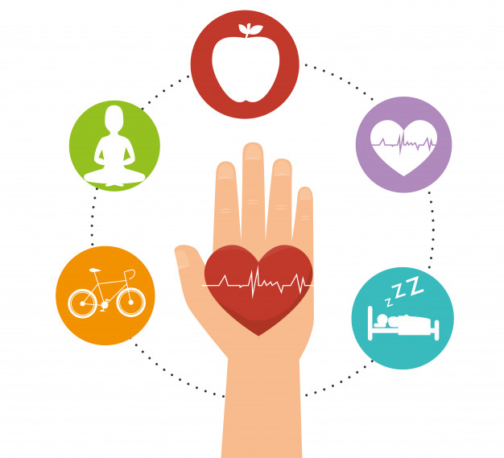

**Let’s Stay in Shape**

**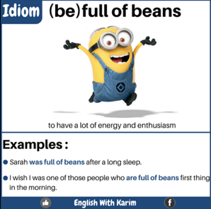**

Chart

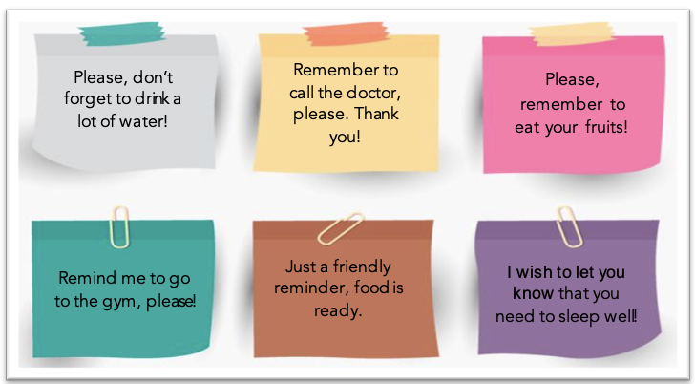

Outline

Recipient of the reminder:

Include polite a phrase/expression:

Include on the reminder types of food:

Include the type of action you want to remind:

Reminder

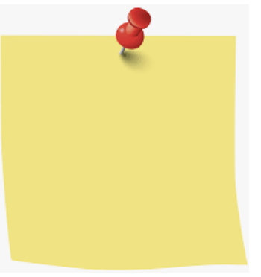

Let’s write a reminder

**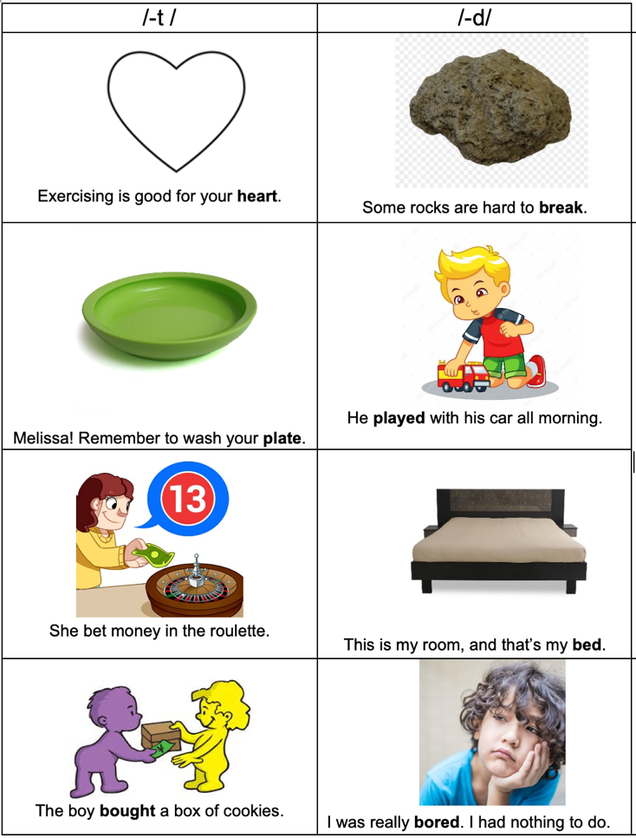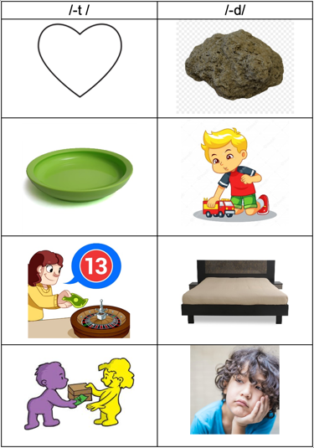**

|  |  |  |  |  |  |
| --- | --- | --- | --- | --- | --- |
| **Term:** | **Level: Fifth Grade** | | **Unit:** | | **Week:4** |
| **Domain: Socio-interpersonal:** Socio-interpersonal | | **Scenario: Healthy Choices, Better Life** | | **Theme:**  Healthy Lifestyles | |
| Almost every day, we do things like count, measure, estimate, and calculate to get things done. We use numbers in sports and shopping. These actions help us be more confident in our decisions and they help us communicate our needs. | | | | | |
| **Essential Question:**  How do we quantify our world every day to lead better lives? | | | | | |
| |  | | --- | | **Dimensions** | | **1.** **Ways of thinking (   )** | | **2. Ways of living in the world  ( )** | | **3. Ways of relating with others  ( )** | | **4. Tools for integrating with the world  ( )** | | | | | | |
| **Learn to Know** | | **Learn to Do** | | **Learn to Be and Live in Community** | |
| **Grammar & Sentence Frames**  **Simple Present** **and Frequency Adverbs**   * I usually eat/drink \_\_\_\_\_. * I exercise once/twice a week.   **Future with going to**   * I am going to eat healthier. * I am going to do more exercise.   **Modal should**   * We should not eat junk food frequently.   **Phonemic Awareness**  Practicing minimal pair sounds:  /-t / heart, plate, bet, bought  /-d/ hard, played, bed, bored  **Vocabulary**  **Healthy Lifestyles**   * How can we keep healthy? * Let´s make a health campaign at school. * Taking care of the body * I have to… I should... * Take a bath/ shower * Brush teeth * Use dental floss * Drink a lot water * Wash hands after using toilets and before meals * Eating healthy food | | **Function**  Describing healthy lifestyles  **Discourse Markers**  Sequence adverbs-past tense  First, next, then, finally | | **Psycho-social**  Leading a healthy life  **Socio-cultural**  Promoting healthy food and healthy habits  **idioms/ phrases**   * In bad shape (poor physical condition)   Facebook | |

|  |  |  |  |  |  |
| --- | --- | --- | --- | --- | --- |
| **Assessment Strategies & Evidences of learning**  (Diagnostic, formative, summative) | **Goals** | | **Pedagogical Mediation/ Didactic Sequence** | | **Time** |
| Learner… | Learner can | | ***CONNECTION***  **Pre-teaching**  *Teacher sets the classroom, leads the routine and quickly checks the attendance. Then T announces the beginning of the new topic. Creative teachers can display a chart with the theme and the idioms they will learn during this week or any other creative idea.*  **Warm up**  T pastes on the board these two charts (or a design a collage), then s/he asks this question:  What activities do you do to have a healthy lifestyle?  Take a bath/ shower  Brush my teeth  T gives sticky notes to the Ss for them to write the response to the question in order to illustrate the students, S/he writes two examples.  Then the Ss come to the board to paste their sticky notes classifying them into two groups: **healthy food** and **healthy habits**.  **Activation of Prior Knowledge**    After the brainstorming activity, T shares with the Ss this sheet by pasting it on the board and will show Ss its use.  T asks Ss the following question:  “How often do you exercise?  Then the teacher shows Ss how to use the adverbs of frequency and expressions to accurately respond to this question.  Once students have gotten familiar with the time expressions and adverbs, the teacher reviews examples with BE GOING TO and the use of the modal SHOULD.      **Modeling**  Then T plays video to explain and illustrate better the use of FA connected with describing personal healthy habits and routines.  <https://www.youtube.com/watch?v=bjbg1QAuXQc>  ***CLARIFICATION***  **Clarifying**  T gives Ss sticky notes and asks them to write a sentence describing one personal healthy habit using frequency adverbs and expressions studied before. After s/he collects the sticky notes and pastes on the board to read it aloud. T takes advantage of the examples to clarify doubts. | | 40 minutes |
| **SI.3.** Makes and accepts suggestions.  **SI.3.1** makes suggestions about healthy lifestyles to others using complete simple sentences  **SI.3.2.** accepts suggestions about healthy lifestyles from others using complete sentences or phrases. | **SI.3.** make and accept advice. | | ***CONNECTION***  **Pre-task**  Ss get familiar with the goal of the lesson.  T brainstorms ideas for having a healthy lifestyle and writes all the examples on the board. Besides, T shows to Ss some model conversations with examples of the type of language they are going to use in the speaking task.    T asks Ss to work in groups of 3-4 for them to prepare a conversation using the new vocabulary they studied in the previous stage. S/he gives them a situation to start working in their conversation. Ss should use frequency “adverbs”, “expressions”, future with “going to” and the modal “should”.  T suggests Ss to use the following phrases to accept suggestions:   1. Thanks! That sounds like a good idea. 2. Thank you! I’m going to… 3. What a good idea!   **TASK**  You are in the school’s garden, in the recess time with a group or friends. The conversation goes around things you do to keep a healthy lifestyle. While the conversation takes place a friend of yours arrives and tells you s/he feels a little sick because the other day s/he ate a lot of junk food and sweets. So that you and your friends tell the friend some suggestions to improve his/her lifestyle.  ***CLARIFICATION***  **Task-rehearsal**  Ss decide on the vocabulary and expressions they will use and draft the conversation. Then they practice the conversation to perform it in from of the class, taking care of rotating their roles in their conversation.  Ss share their conversations with other groups to receive feedback. T monitors the activity and the time.  ***CONSTRUCTION & APPLICATION***  **Task completion**  Once Ss have rehearsed the conversation they take turns to perform the situation.  ***COLLABORATION***  **Task assessment**  /var/folders/4s/0g_lyff907n4m_ksnpb59sph0000gn/T/com.microsoft.Word/Content.MSO/250930DC.tmp/var/folders/4s/0g_lyff907n4m_ksnpb59sph0000gn/T/com.microsoft.Word/Content.MSO/250930DC.tmpLearners work on self-assessment, as well as the whole class assesses their achievement of the goal.  Achieved Not yet | | 40 minutes |
| **W2.** Copies dates and facts from short, simple text.  **W.2.1** identifiesdates and facts from short, simple text by filling a chart.  **W.2.2** copies dates and facts from short, simple text in charts and graphs. | **W2.** Copy dates and facts from short, simple text. | | ***CONNECTION***  **Pre-task**    T shares the goal of the lesson.  T shows a schedule and some activities with the dates and times they are practiced.  T asks questions to students to identify dates and facts about Fernanda’s schedule.  Example:   * When is Fernanda going to play soccer? * She is going to the gym on Wednesday, September 8th.   ***CLARIFICATION***  **Task-rehearsal**  Ss look at Fernanda’s schedule and answer the question below.   * When is Fernanda going to do the following activities?  |  |  | | --- | --- | | Activities | Dates | |  |  | |  |  | |  |  | |  |  |   ***CONSTRUCTION & APPLICATION***  **Task completion**  T gives the student a writing task and asks them to work individually in order to complete a short message about their own week schedule.  **TASK**  Fernanda is going to write an e-mail to her friend Manuel talking about her family, especially what she is going to do during the week to improve her lifestyle. Using Fernanda’s schedule, copy the missing information in the e-mail. Pay attention to spelling, capitalization, and word order.    ***COLLABORATION***  **Task assessment**  At the end of the task, students will check their development of the task by co-assessing their classmates’ e-mails using a short rubric and short rating scale.     |  |  |  | | --- | --- | --- | | Co-assessment Rubric  Name: \_\_\_\_\_\_\_\_\_\_\_\_\_\_\_\_\_\_\_\_\_\_\_\_\_\_\_ | Achieved | Not Achieved | | My classmate copies Fernanda’s activities according to the schedule. |  |  | | My classmate copies Fernanda’s dates according to the schedule. |  |  | | My classmate uses capitalization when writing days and months. |  |  | | My classmate writes the words with correct spelling. |  |  | | My classmate uses correct word order to write the activities. |  |  |   Ss will rate their classmates coloring hearts according to the thumbs up the got in the co-assessment rubric.  **Rating Scale** | | 40 minutes |
| **PA.2.** Shows knowledge of phonemic awareness by pronouncing the sound /-t/, /-d/ at the end of words.  PA.2.1. identifies the pronunciation of endings /t/ and /d/ in regular past tense words when listening and when reading to sets of words and sentences.  P.A.2.2. produces the endings /t/ and /d/ when reading words and sentences that represent regular past tense verbs. |  | | ***CONNECTION***  **Pre-task**  Ss get familiar with the goal of the lesson.  The teacher explains that minimal pairs are words that vary by only a single sound, for example /t/ and /d/. Teacher provides examples and asks learners to repeat after her/him.  Teachers can look for different words with the /t/, /d/ sounds.    ***CLARIFICATION***  **Task-rehearsal**  Learners play ‘**Run and Grab’**. The teacher sticks the cards with the minimal pair on the board. The class is divided into two teams, and then a member of each team stands at the back of the room, looking down an aisle at the board. The teacher calls one of the minimal pairs out, and the pair of students races to the front to touch the correct words on the board or grab the appropriate flashcards. Student from the winning team could have a turn calling the words for others to run.  ***CONSTRUCTION & APPLICATION***  **Task completion**  Teacher divides the group into pairs to play **‘Running Dictation’ One** student runs to read the words from somewhere farther away, like on the wall outside the classroom. They then dictate to the other student who writes them down. The teacher monitors learners’ performance when reading the target words: The difference between words with /t/ sound and /d/ sound. Learners switch places and it is now time for the other student to dictate.  **Task assessment**  Learners play **‘Crumple and Shoot Basketball’** The minimal pair words are written on pieces of (scrap) paper. Students are lined up in two teams. In turn, the front student picks up the paper and reads the word. If it’s read correctly, they then crumple it up and throw it into a basket a set distance away. (Getting it into the basket wins another point.)  ***COLLABORATION***  Learners work on self and peer assessment. Whole class assesses their achievement of the goal.    *Taken from “Teacher’s guide 4th grade-theme3”.* | | 40 minutes |
| **Integrated Mini-Project** | | | | | **Time** |
| Phases   * **Planning:**The class is divided into two groups (A-B) and each group is divided into pairs. Learners are told they are going to prepare a Cooking Magazine to show how to make simple recipes. Each pair finds a recipe for a meal of their choice. The magazine should have a cover and a section with advices for a healthy life style. * **Creating:** Learners write the ingredients, quantities and healthy value of their recipes. Learners can bring cut-outs form newspapers, old cooking magazines or from the internet to decorate its own magazine. * **Rehearsing:** Learners rehearse their presentation of the magazine to the group. * **Participating:** Each of the two groups (A-B) will present their magazine to the class. The teacher can record each presentation in a video (if parents agree) and the videos can be presented to the whole class. * **Presenting:** In the week six, the two groups will present their magazines to the groups. If the classroom has a reading corner, learners can leave their magazines there as part of the reading corner for others’ learners. | | | | |  |
| **Reflective Teaching** | | | | | |
| What worked well | | What didn’t work well | | How to improve | |
| **Enduring Understanding Reflection** | | | | | |
|  | | | | | |

|  |  |  |  |
| --- | --- | --- | --- |
| Learner self-assessment | | | |
| I can … | Yes | Sort of | No. Help! |
| SI.3.1 makes suggestions about healthy lifestyles to others using complete simple sentences |  |  |  |
| SI.3.2. accepts suggestions about healthy lifestyles from others using complete sentences or phrases. |  |  |  |
| W.2.1 identifies dates and facts from short, simple text by filling a chart. |  |  |  |
| W.2.2 copies dates and facts from short, simple text in charts and graphs. |  |  |  |
| PA.2.1. identifies the pronunciation of endings /t/ and /d/ in regular past tense words when listening and when reading to sets of words and sentences. |  |  |  |
| P.A.2.2. produces the endings /t/ and /d/ when reading words and sentences that represent regular past tense verbs. |  |  |  |

**Theme 4 Resources**

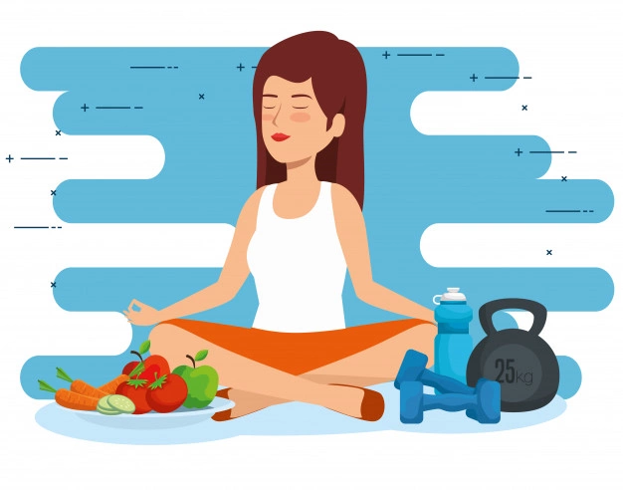

**Healthy Life Styles**

**Charts**

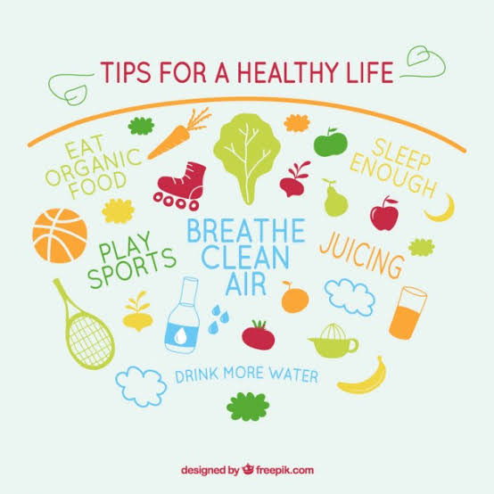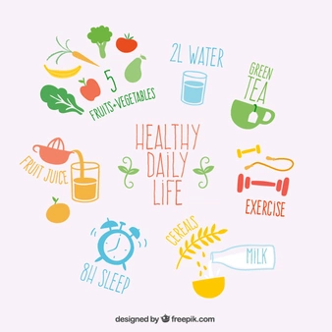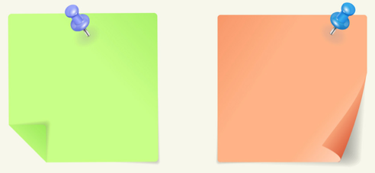

Take a bath/ shower

Brush my teeth

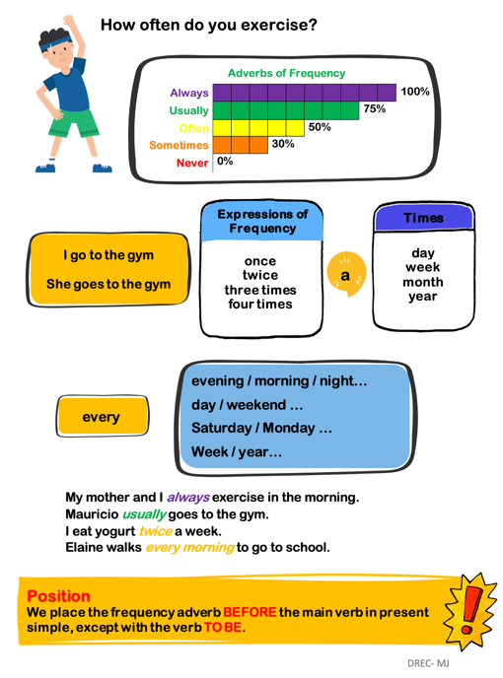

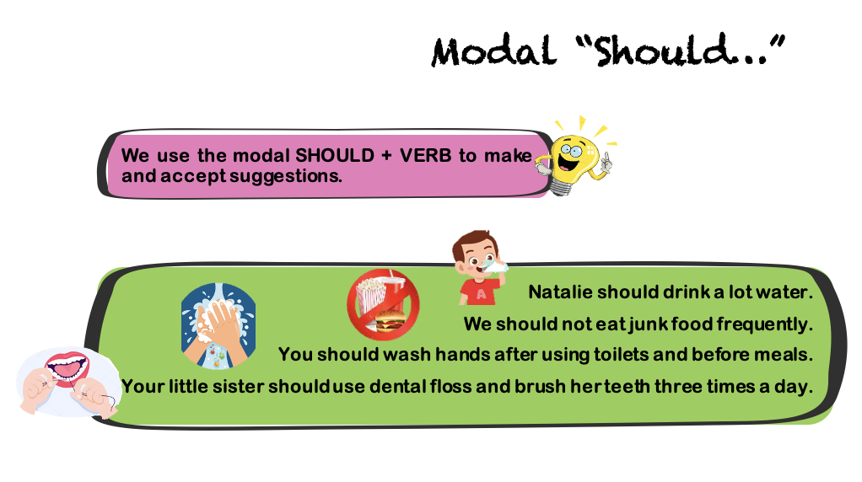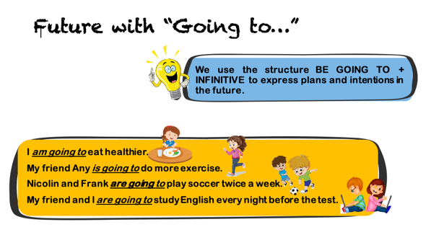

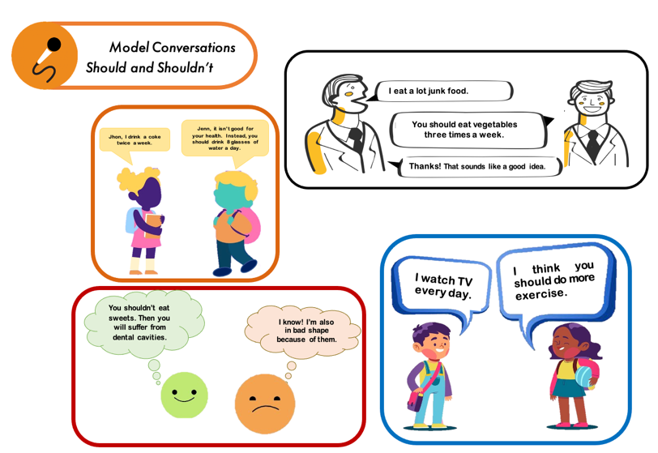

**Model Conversations**

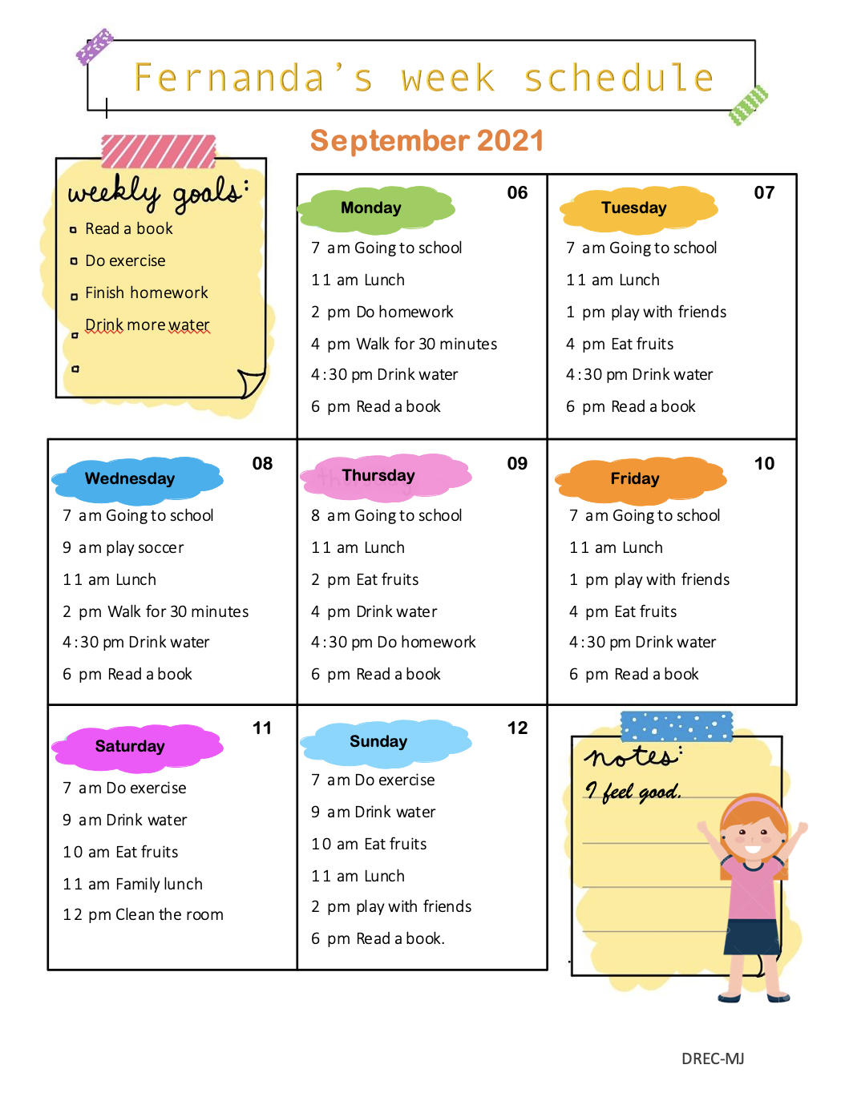

**Schedule**

**Writing Task**

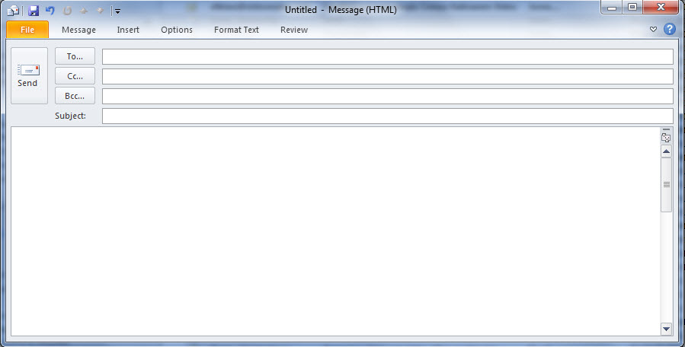

Dear friend Manuel, I hope this email finds you well. My family and I have been so busy last month. We are trying to improve our health’s habits. So that all the family is doing more physical activity, drinking more water and eating healthy food.

I’m going to tell you about my routines during the week. On \_\_\_\_\_\_\_\_\_\_\_\_ I’m going to walk for 30 minutes. On Tuesday, September \_\_\_\_\_, I’m \_\_\_\_\_\_\_\_\_\_\_\_\_\_\_\_\_\_\_\_\_\_\_\_\_\_\_\_\_\_\_\_\_\_\_\_\_\_\_\_\_\_, I’m \_\_\_\_\_\_\_\_\_\_\_\_\_\_\_\_\_\_\_\_\_\_\_\_\_\_\_\_\_\_\_\_\_\_ on \_\_\_\_\_\_\_\_\_\_\_\_\_\_\_\_\_\_\_ at \_\_\_\_\_\_\_a.m. On Thursday I \_\_\_\_\_\_\_\_\_\_\_\_\_\_\_\_\_\_\_\_\_\_\_\_\_\_\_\_\_\_\_\_\_\_\_\_\_ at \_\_\_\_\_\_\_\_. On \_\_\_\_\_\_\_\_\_\_\_\_\_\_\_\_\_ and \_\_\_\_\_\_\_\_\_\_\_\_\_\_\_\_\_ I \_\_\_\_\_\_\_\_\_\_\_\_\_\_\_\_\_\_\_\_\_\_\_\_\_\_\_\_\_\_\_\_\_\_\_\_\_ at \_\_\_\_\_\_\_\_ a.m.

As you can see Manuel, I am working so hard and I hope you and your family too.

My family sends you good vibes.

Best regards,

Fernanda

**manuel2021@gmail.com**

**Greetings from my family.**

**Suggested Websites**

<https://www.youtube.com/watch?v=KC-8AvunL8Y>

<https://www.youtube.com/watch?v=fE8lezHs19s>

<https://www.powtoon.com/s/bhmZUiZSqax/1/m>

<https://drive.google.com/file/d/1D4R-m4hJ2mvESQOQI2dnbd7gnQbkFqXb/view?usp=sharing>

<https://youtu.be/k-besF9yuHY> (conversation about food)

<https://www.youtube.com/watch?v=tlugFP6lzuM>

<https://www.youtube.com/watch?v=zlOZMyOb4iE>

<https://youtu.be/VFGSauN2Dbs>

<https://www.youtube.com/watch?v=Lm_dtIGRSzI>

<https://www.youtube.com/watch?v=oLaJ4jyKBUY>

<https://www.youtube.com/watch?v=UxnEuj1c0sw>

<https://www.youtube.com/watch?v=VlPfxokADXY>

<https://www.youtube.com/watch?v=yZgiaQVKNY4>

<https://www.youtube.com/watch?v=R_GYAs2v1Ac>

<https://www.youtube.com/watch?v=bjbg1QAuXQc>

<https://www.youtube.com/watch?v=R_GYAs2v1Ac> (supporting material for frequency adverbs)

<https://www.eslprintables.com/vocabulary_worksheets/food/containers/FOOD_CONTAINERS_348263/>

CREDITS

*Pictures:*

*Bigstock*

*Shutterstock*

*Freepik.com*

*Vector Stock*

*Depositphotos*

*Dreamstime.com*

*Vector-images.com*

*Teacher’s guide 4th grade*

Videos:

*Rock & Learn.com*

*TURTLEDIARY.COM*

*PowToon*

*Youtube.com*

Video editors:

*App.clipchamp.com*

Worksheets:

*Eslprintables.com*

Elaboration and Materials’ Design

*MSc. Merlyn Jiménez Rodríguez*

*English Regional Advisor – DRE Coto*

*Revision and final edition*

*Lic.Randall Centeno Hernandez, national English Advisor, Department of First and Second Cycles*

*Dra. Ana Isabel Campos Centeno, , national English Advisor, Department of First and Second Cycles*

*MSc. Merlyn Jiménez Rodríguez*

*English Regional Advisor – DRE Coto*